**Índice de Documentos**

**Documentos 2.1 2**

**Documentos 2.2 4**

**Documentos 2.3 11**

**Documentos 3.2.1 16**

**Documentos 3.3.1 22**

**Documentos 3.3.2 35**

**Documentos 3.3.3 36**

**Documentos 3.3.4 46**

**Documentos 3.3.5 48**

**Documentos 3.3.6 61**

**Documentos 3.3.7 63**

**Documentos 5.5 68**

**Documentos 6.1.1 88**

**Documentos 6.3.1 97**

**Documentos 6.4 111**

# Documentos 2.1



Macintosh HD:Users:mjack:Documents:Memorial:SituaçãoFuncional.pdf

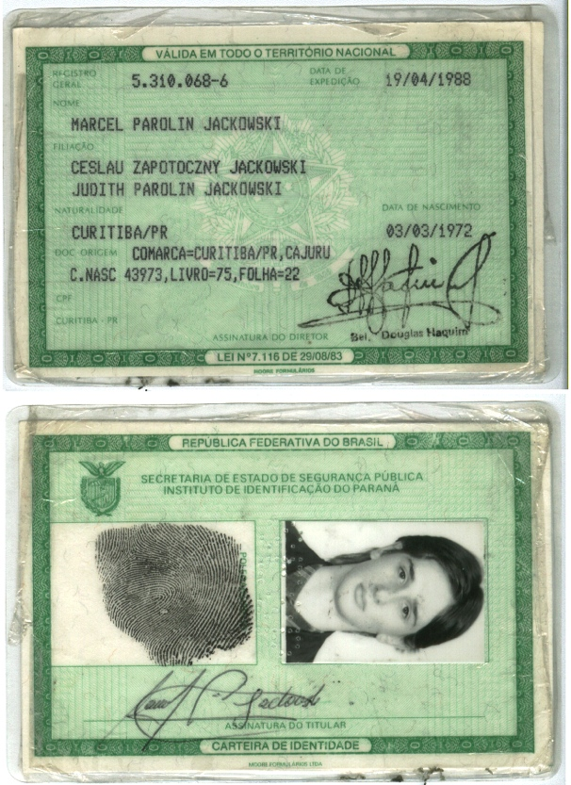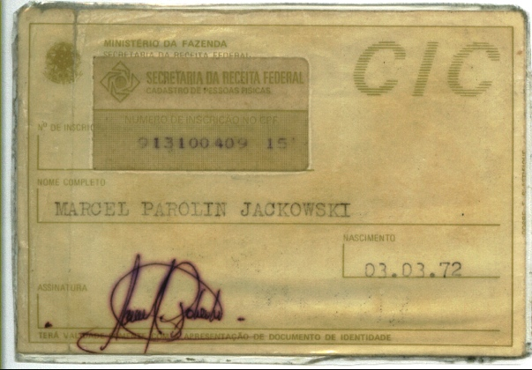

# Documentos 2.2







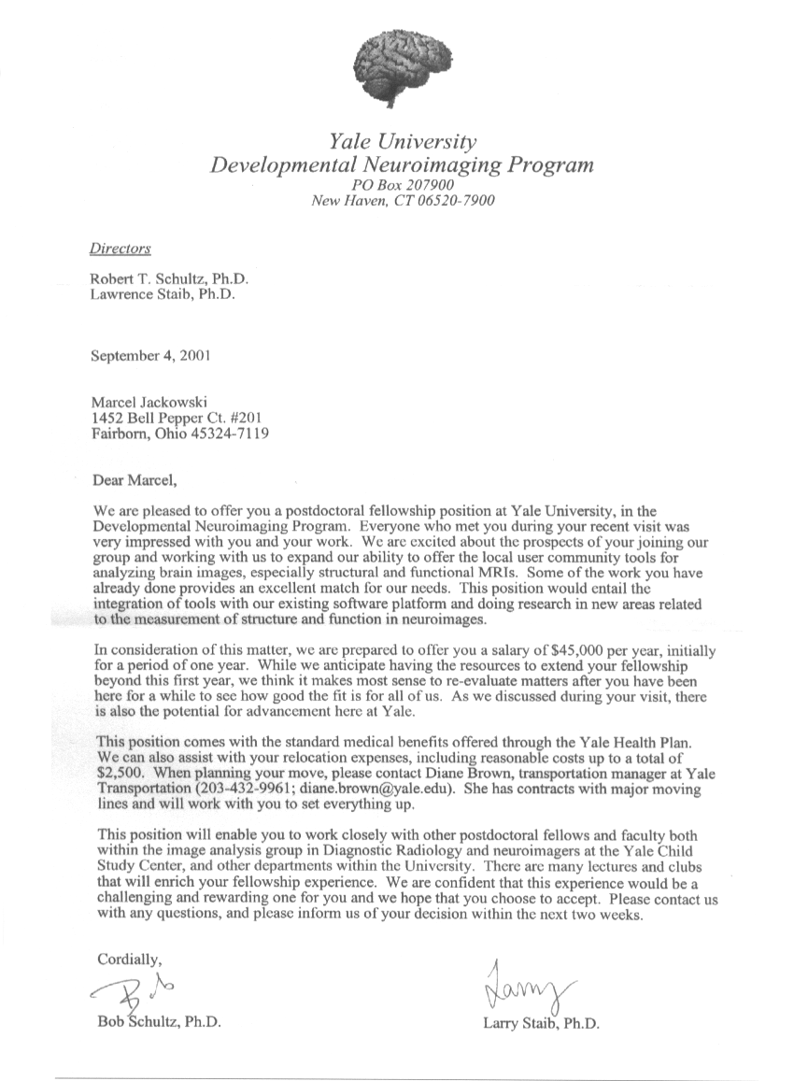

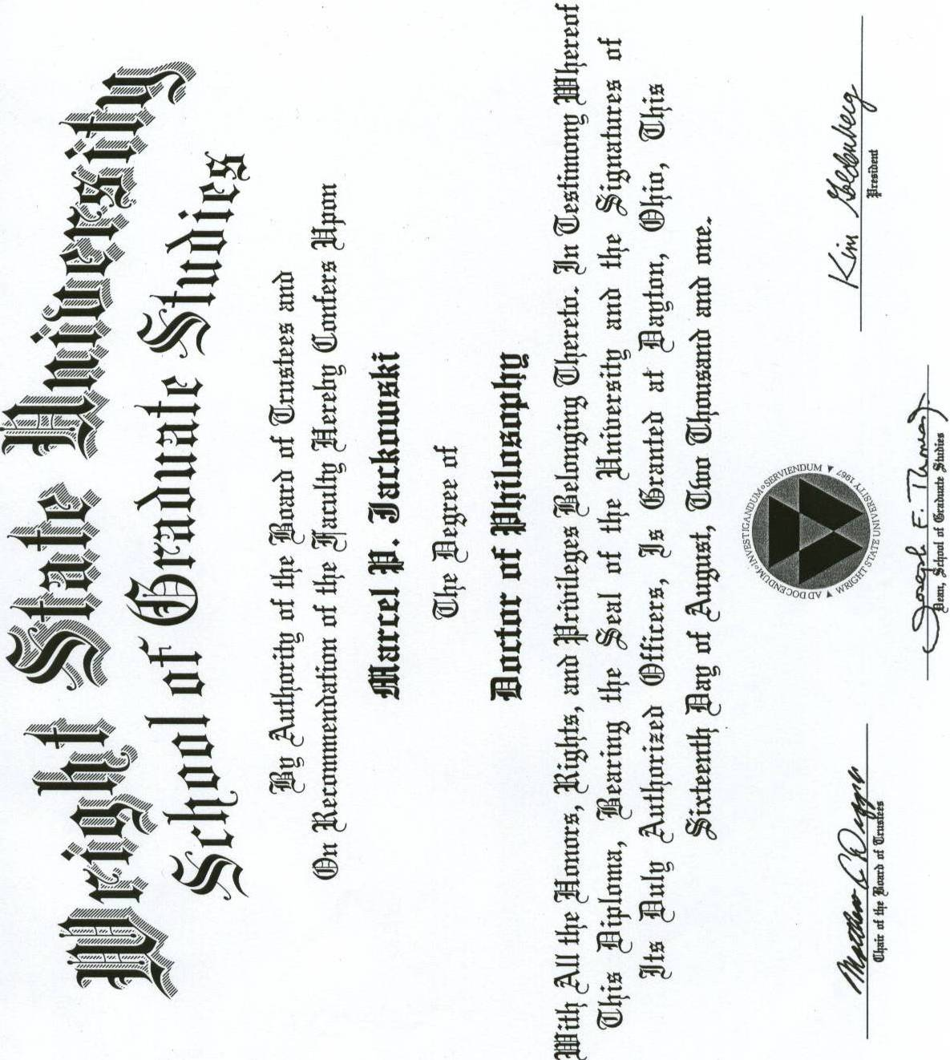

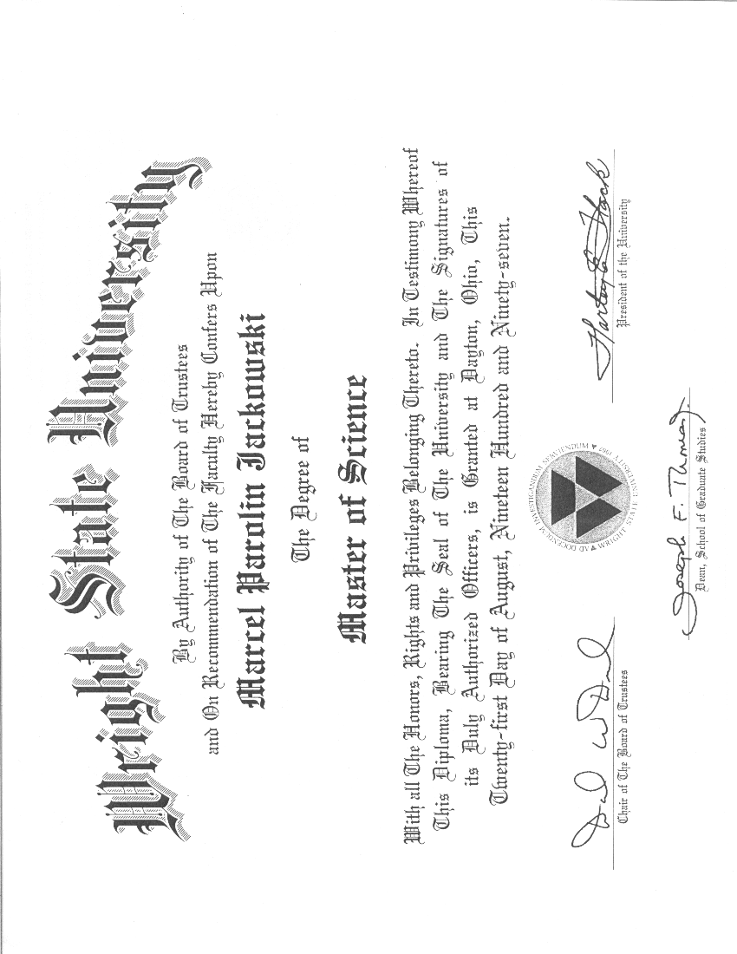

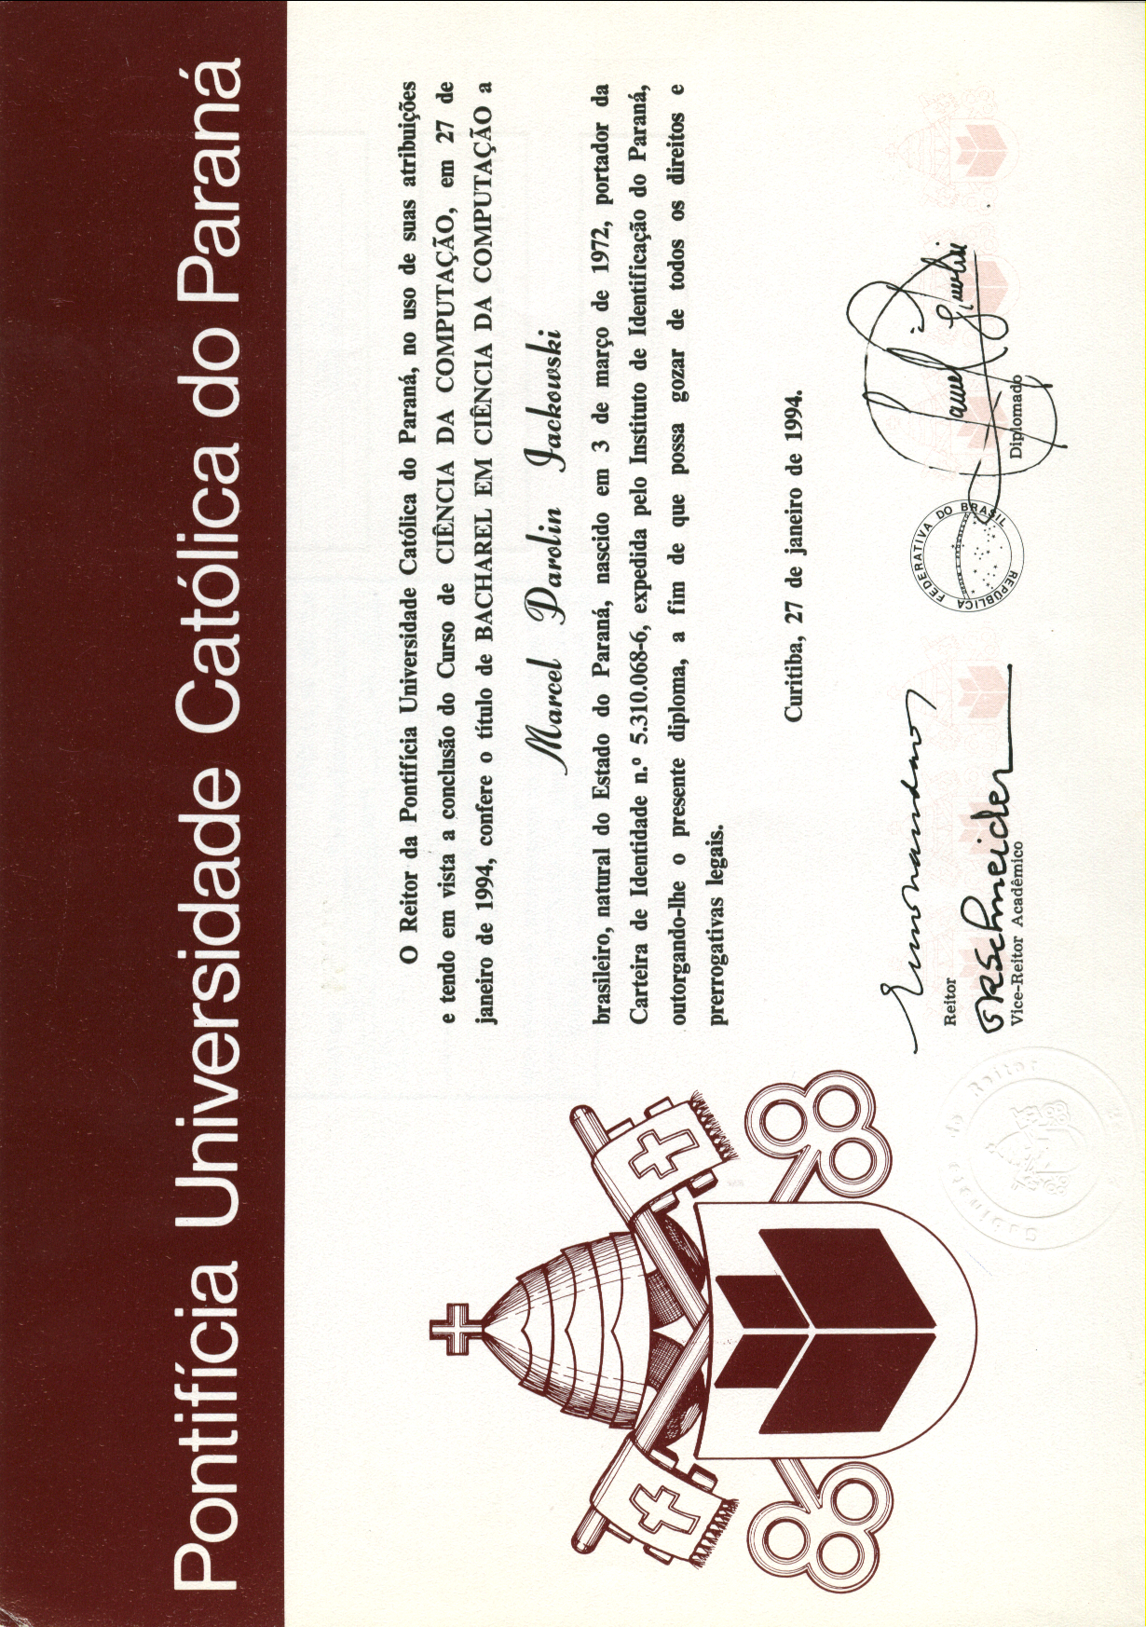

# Documentos 2.3

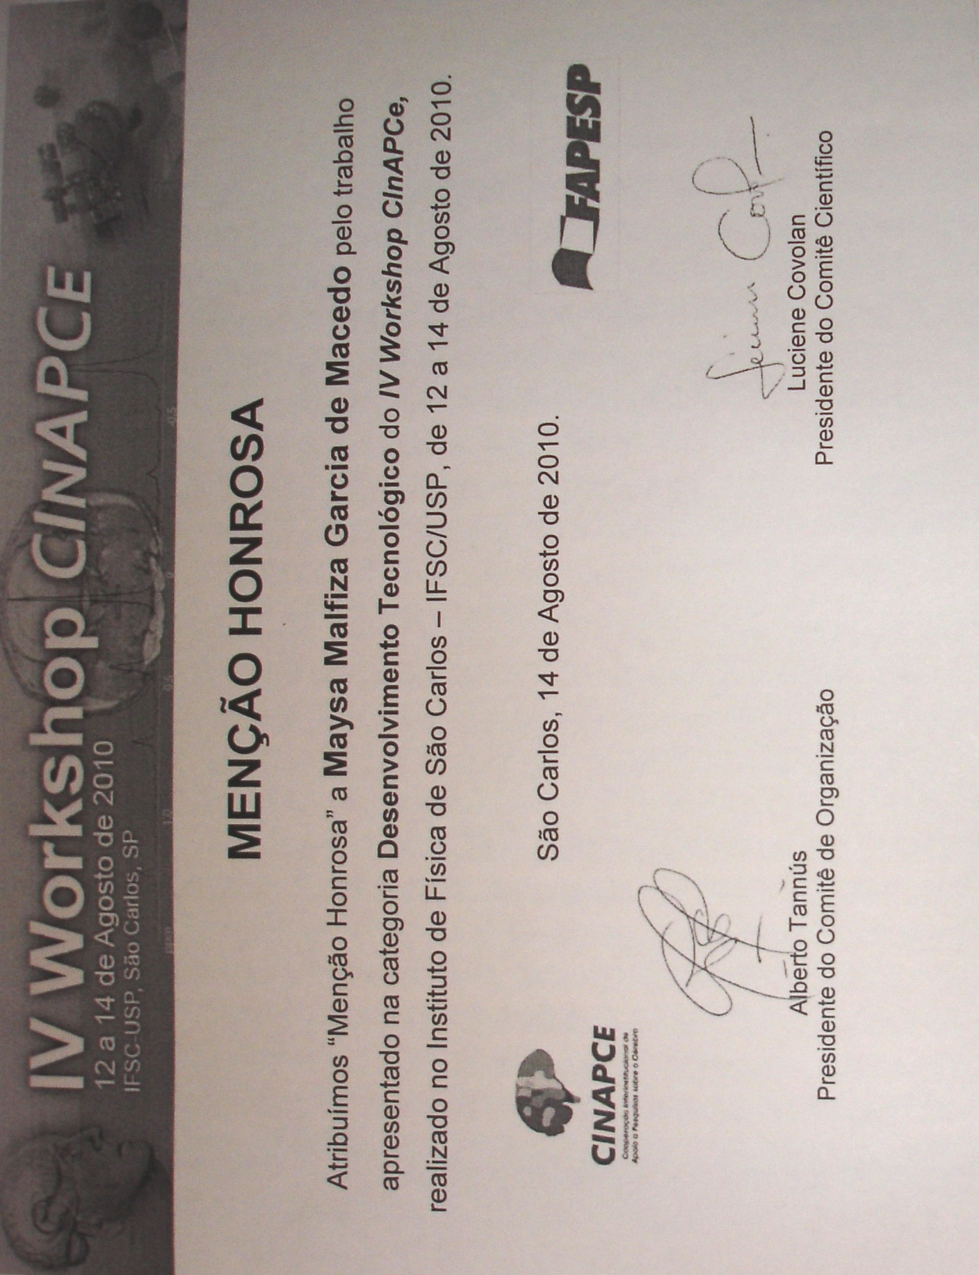

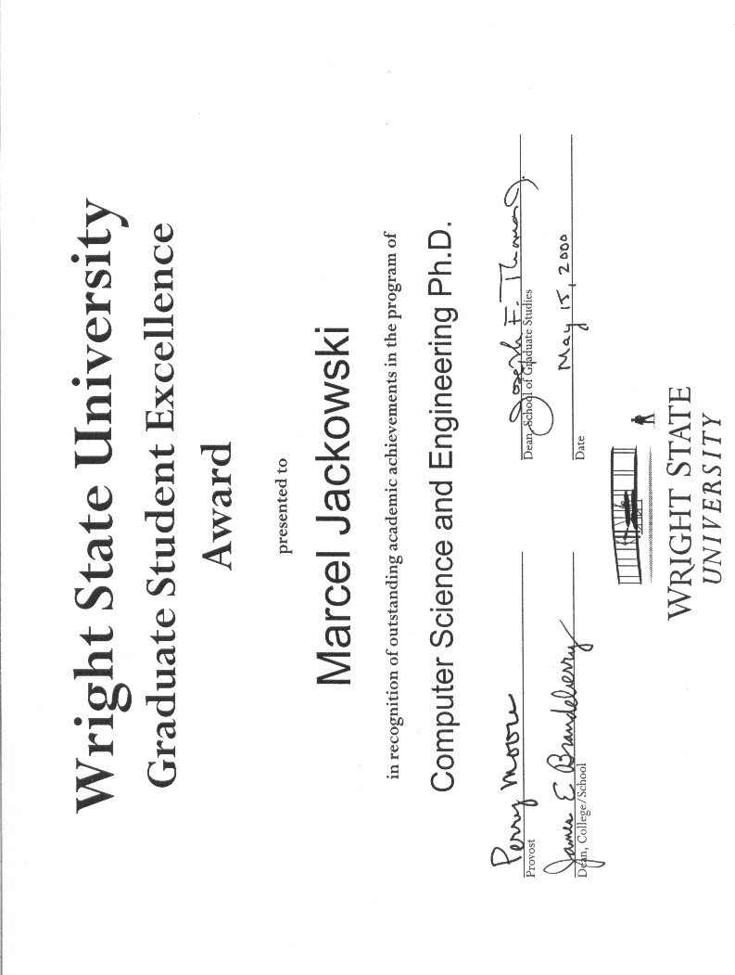

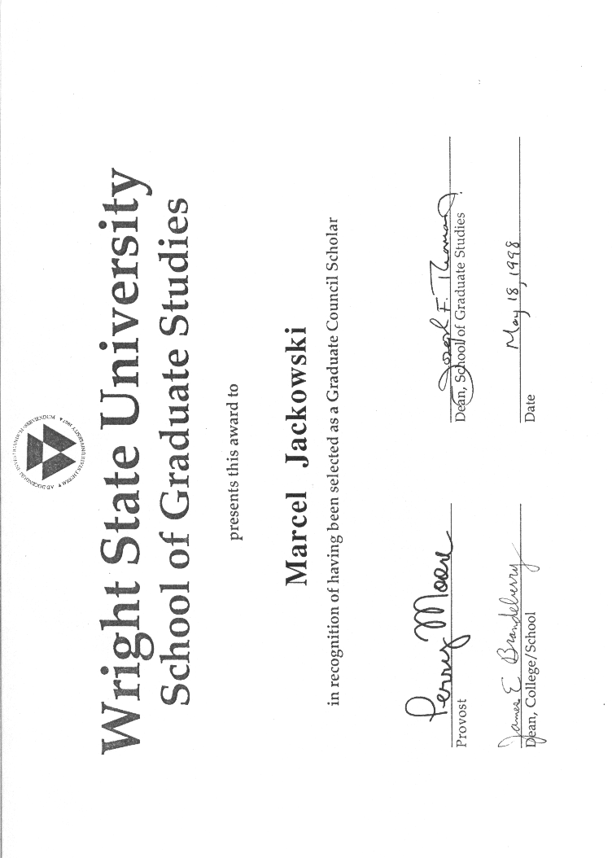

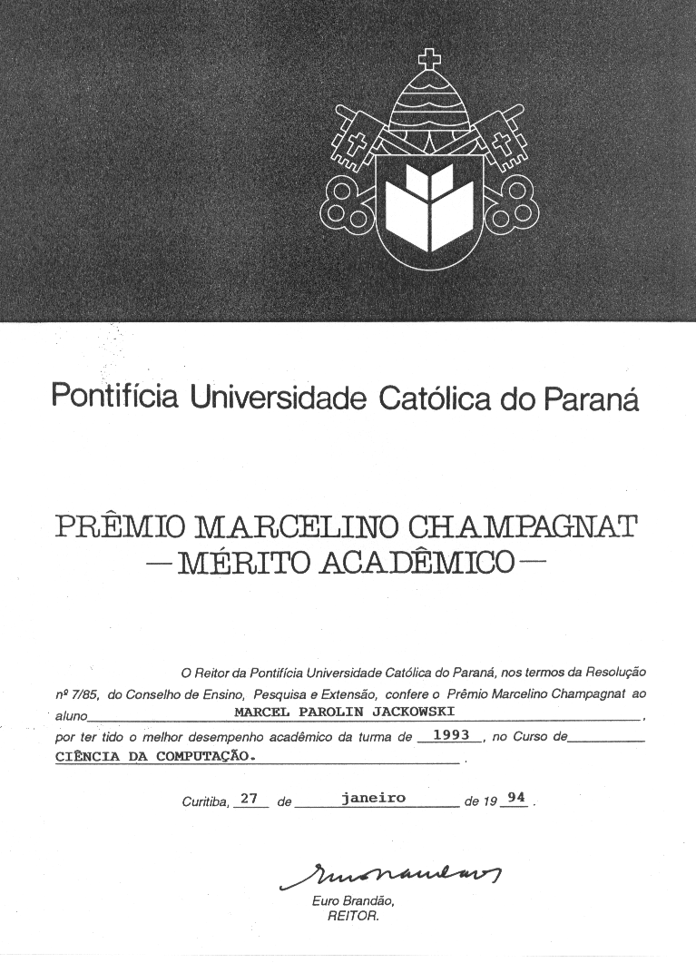

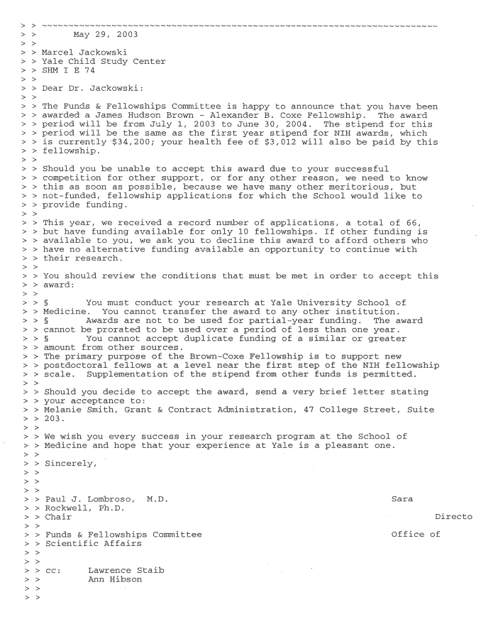

# Documentos 3.2.1



(FAPESP2011.pdf)



(ISMRM2011.pdf)



(ISMRM2009.pdf)

---------- Forwarded message ----------

From: CNPq <dph@cnpq.br>

Date: 2010/12/3

Subject: CNPq - Resultado do julgamento - [560165/2010-2] - Edital nº

09/2010 - PDI - Grande Porte

To: nina.hirata@pq.cnpq.br

Cc: cgcex@cnpq.br

Nome: Nina Sumiko Tomita Hirata

Processo: 560165/2010-2

Projeto: Métodos e Técnicas para Exploração e Análise de Bioimagens

Prezado (a) Senhor(a),

Comunicamos que, com base na recomendação do Comitê Julgador do

PROGRAMA DE CIENCIA E TECNOLOGIA DA INFORMAÇÃO - CTINFO e de acordo

com o que estabelece o Edital nº 09/2010 - PDI - Grande Porte, a

Diretoria do CNPq aprovou a concessão de auxílio para o

desenvolvimento do seu projeto, conforme discriminado abaixo:

  Custeio: R$ 15.502,32

  Capital: R$ 203.650,00

  Bolsas concedidas:

     Modalidade/Nível: DTI-3

     Quantidade: 1

     Duração: 24 meses

Para a implementação do benefício é necessário preencher o Termo de

Concessão e Aceitação que se encontra na página do CNPq, no endereço

http://efomento.cnpq.br/efomento/termo?token=MxU82608C369942091626820801336

e enviá-lo eletronicamente com a MÁXIMA BREVIDADE, clicando no botão

"Enviar ao CNPq".

Atenciosamente,

Glaucius Oliva

Diretor de Engenharias, Ciências Exatas e Humanas e Sociais

(Projeto CNPq – Profa. Nina Hirata)





(NAPNA.pdf)

# Documentos 3.3.1

**Macintosh HD:Users:mjack:Documents:Memorial:li-mueller-med-phys-2010.pdf**

(li-mueller-med-phys-2010.pdf)

(MEDIA_2009.pdf)



(reprint1.pdf)



(PIIS0006322309004247.pdf)



(nihms178051.pdf)



(nihms178049.pdf)



(nihms115760.pdf)



(nihms-123818.pdf)



(13491-full.pdf)



(Jackowski2008.pdf)

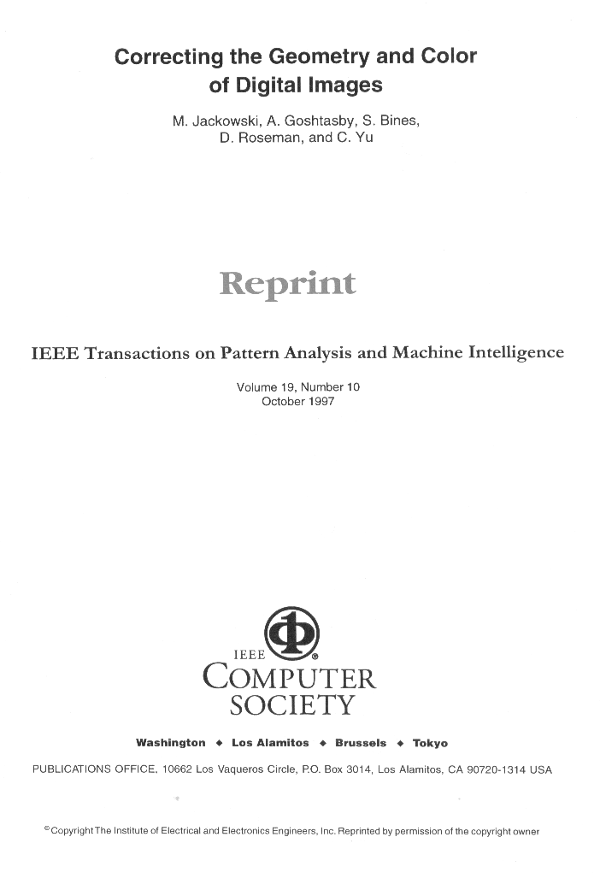

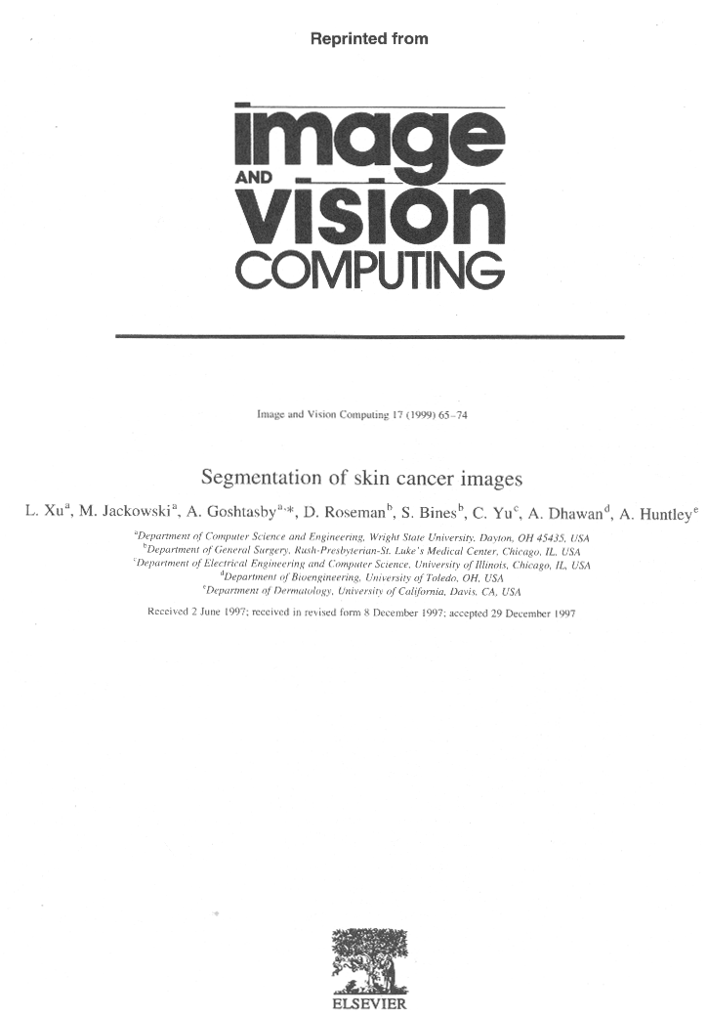

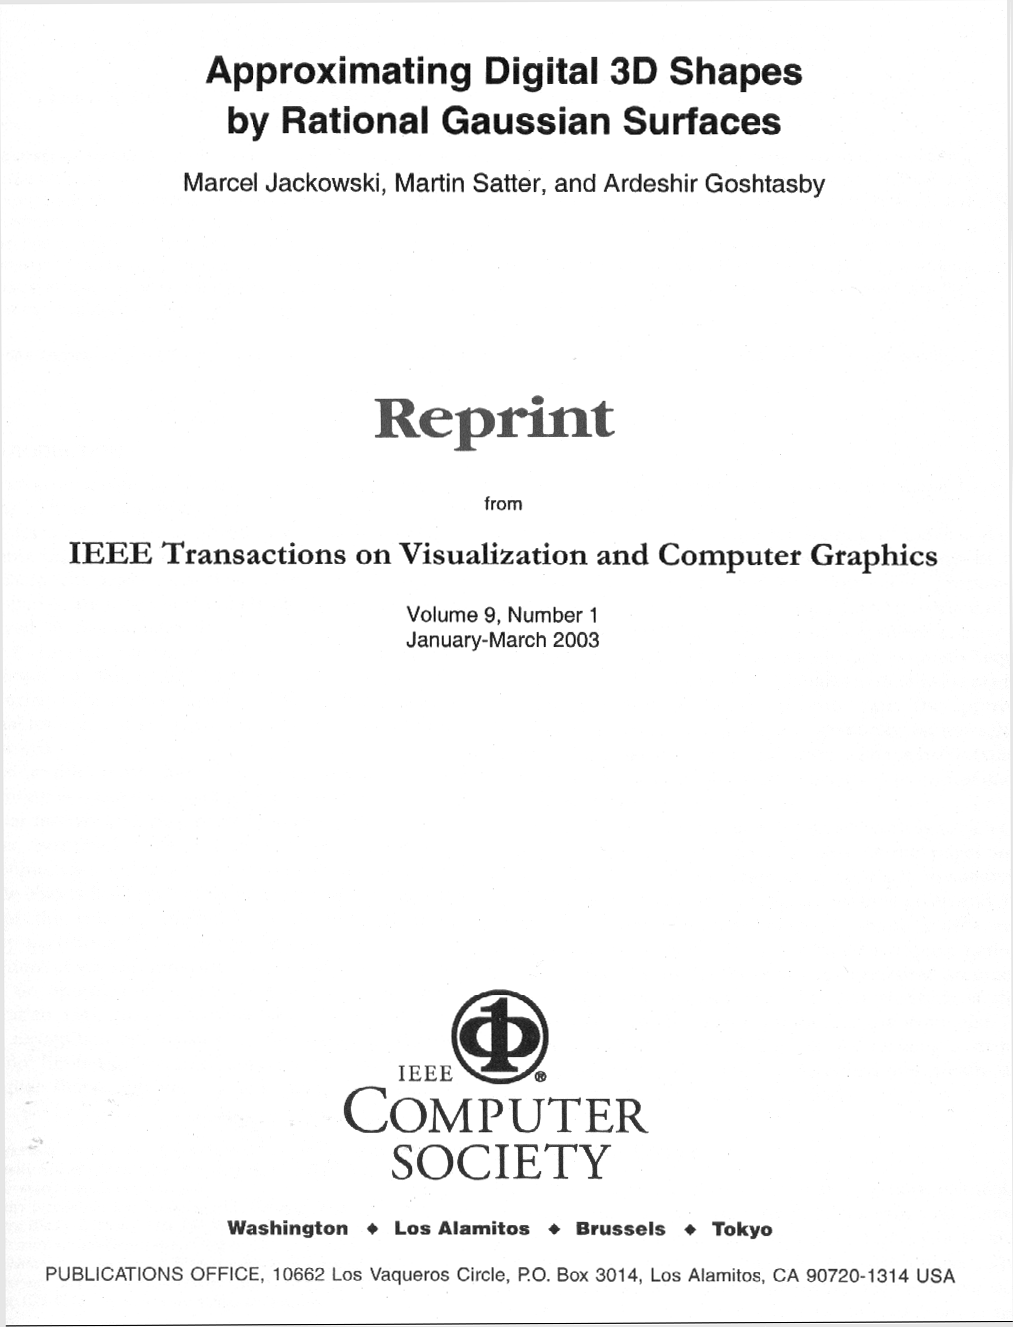

# Documentos 3.3.2

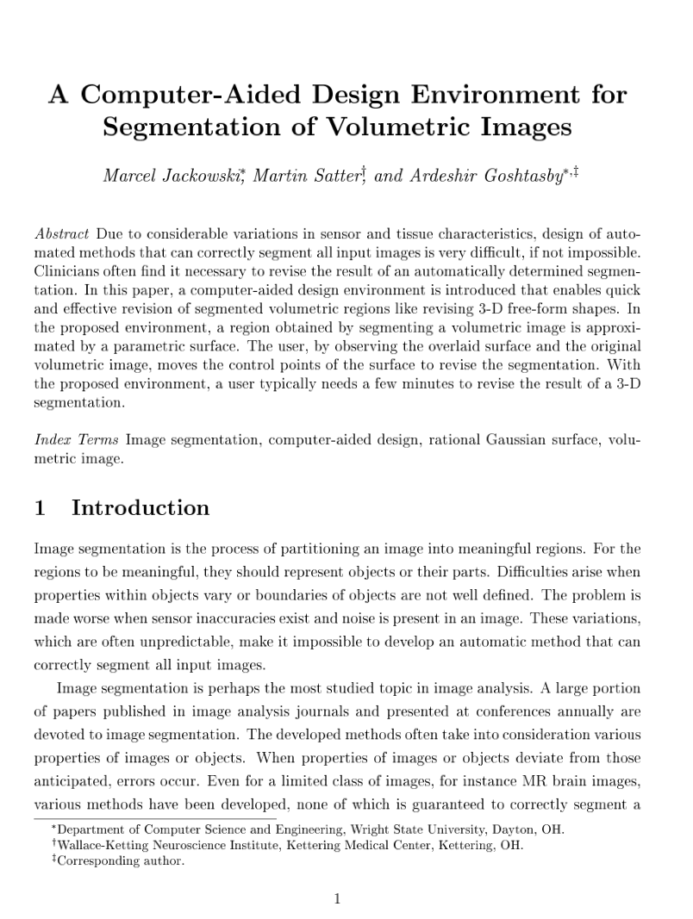

(Book-chapter.PDF)

# Documentos 3.3.3



(ciarp2010cameraready.pdf)



(MICCAI08_final_submit.pdf)



(ISBI_UCT.pdf)

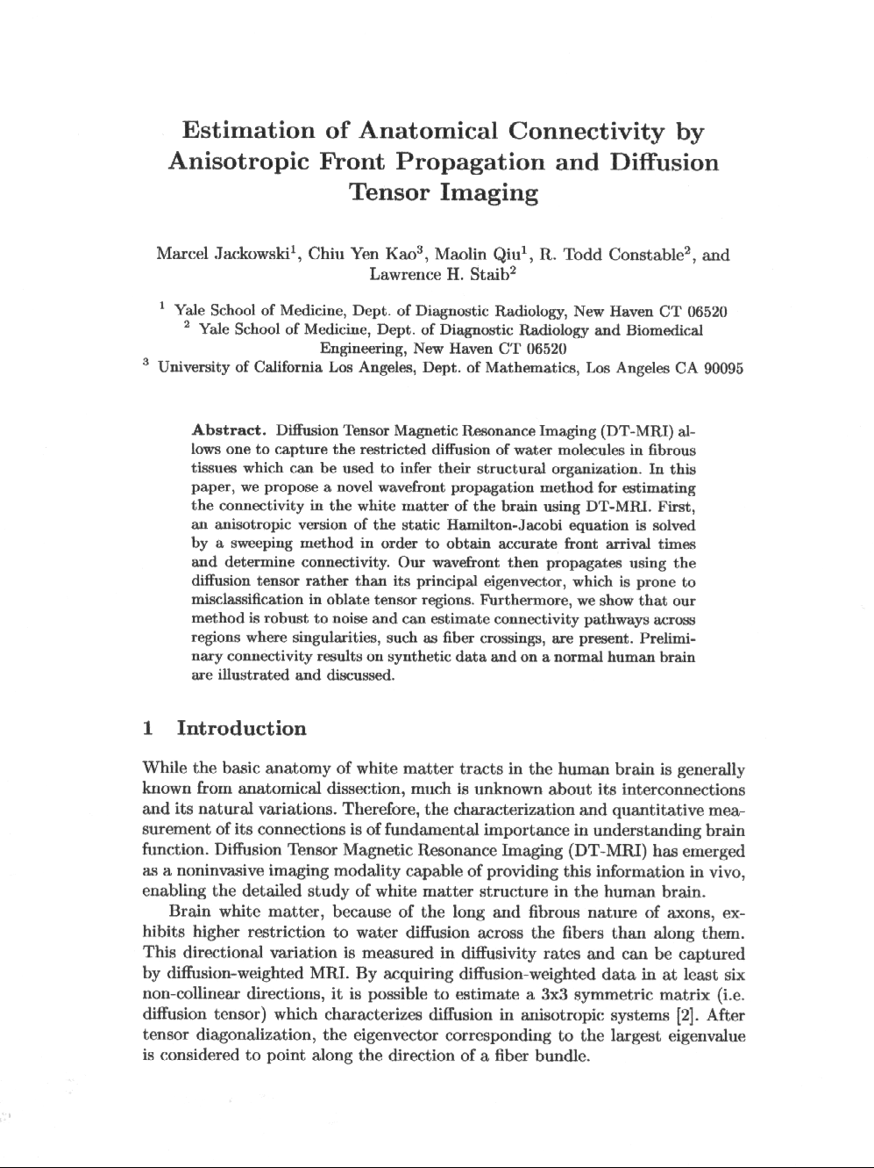

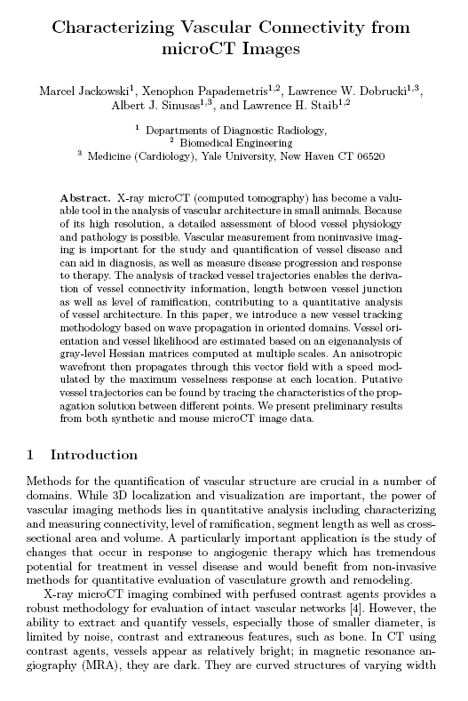

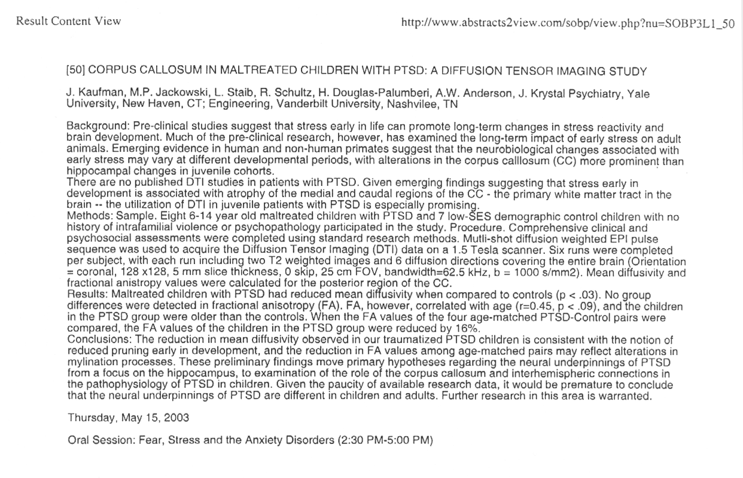

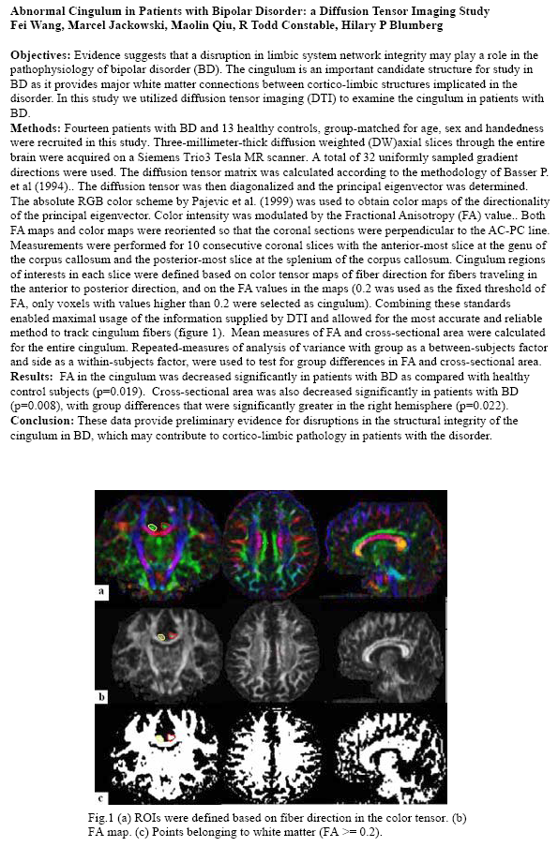

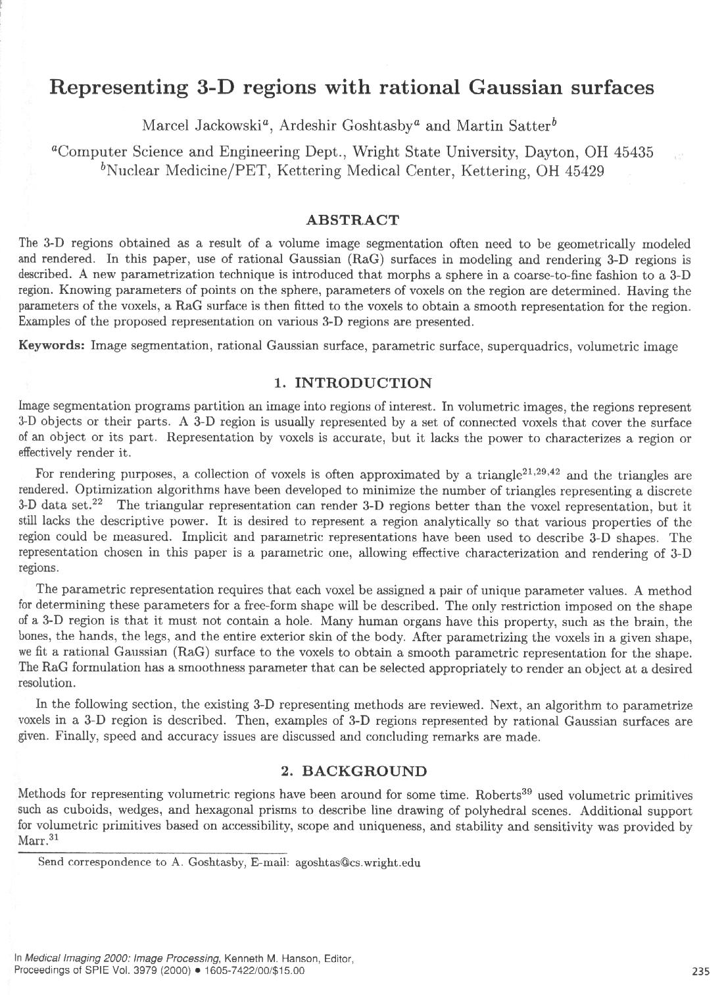

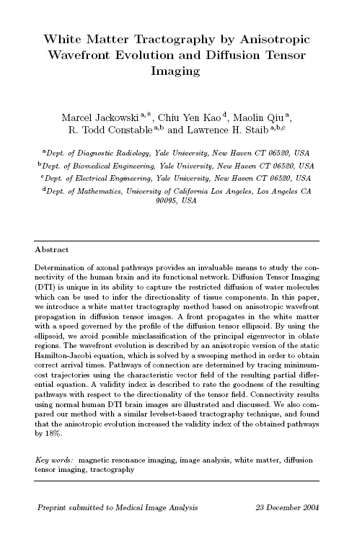

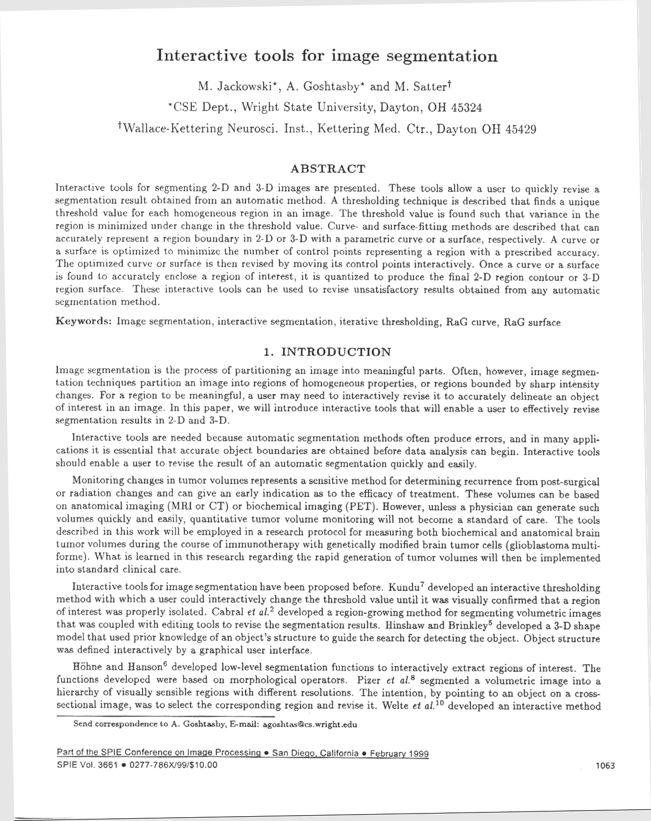

# Documentos 3.3.4



(Sibgrapi2010-Luiz.PDF)



(william-sibgrapi2010.PDF)

# Documentos 3.3.5









# Documentos 3.3.6





(Jihan_dissertacao.pdf)

# Documentos 3.3.7

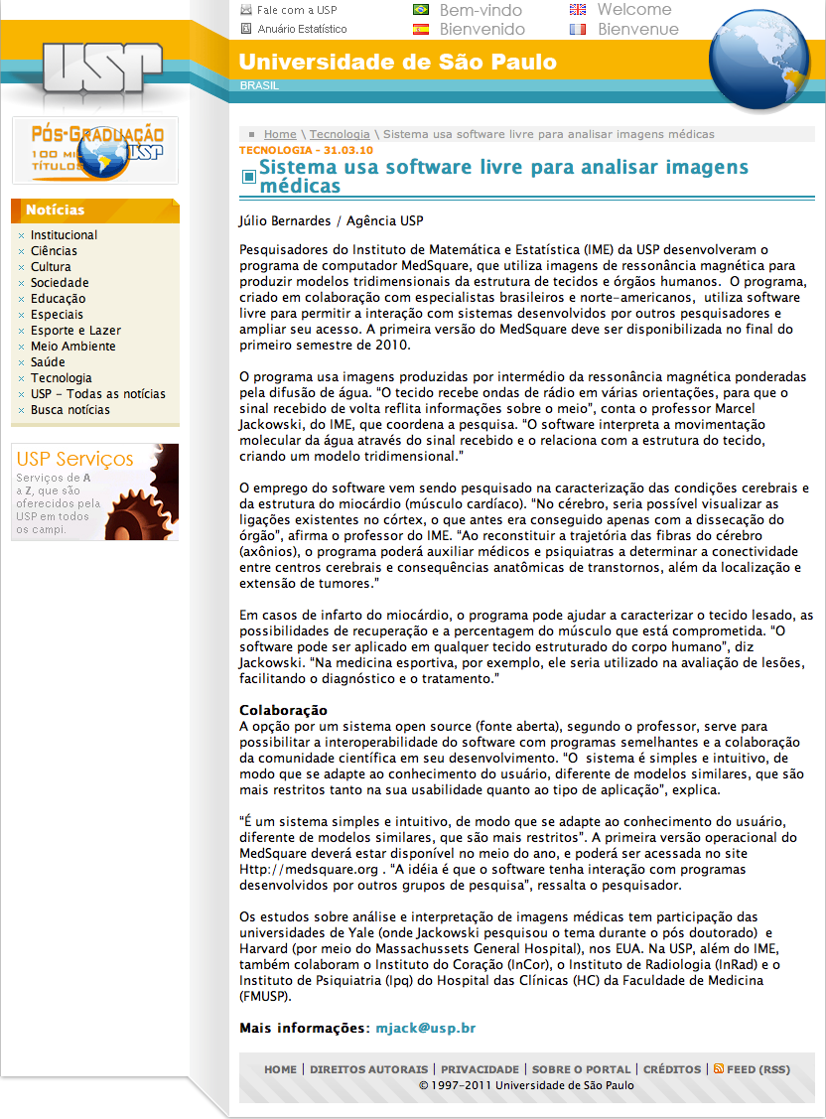

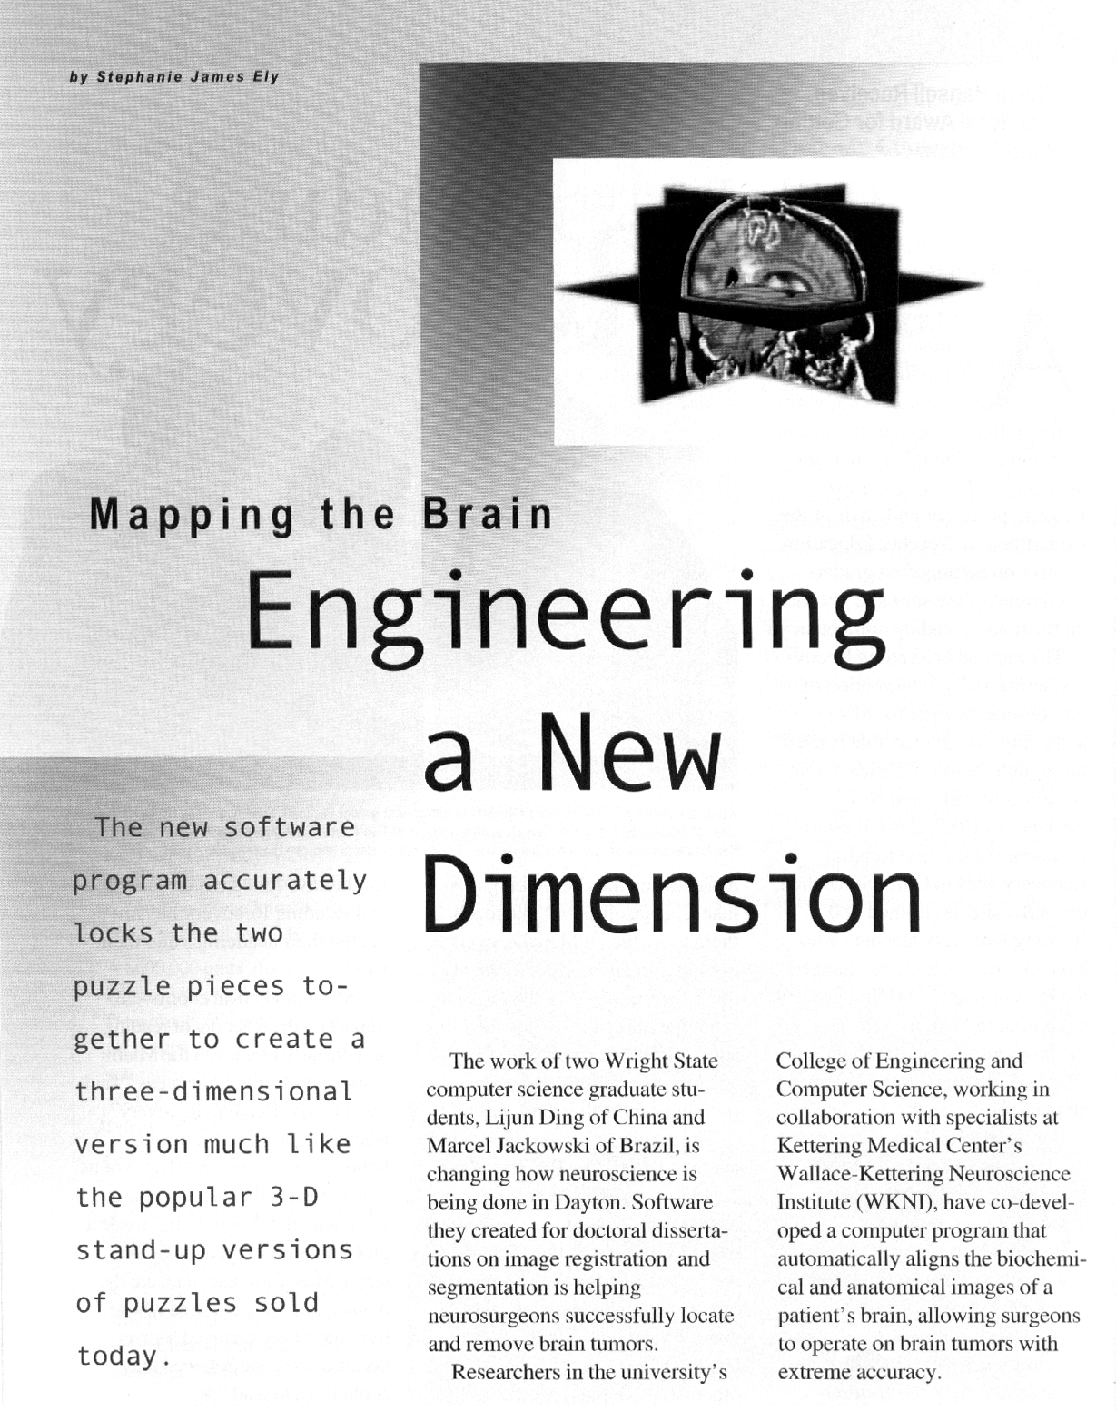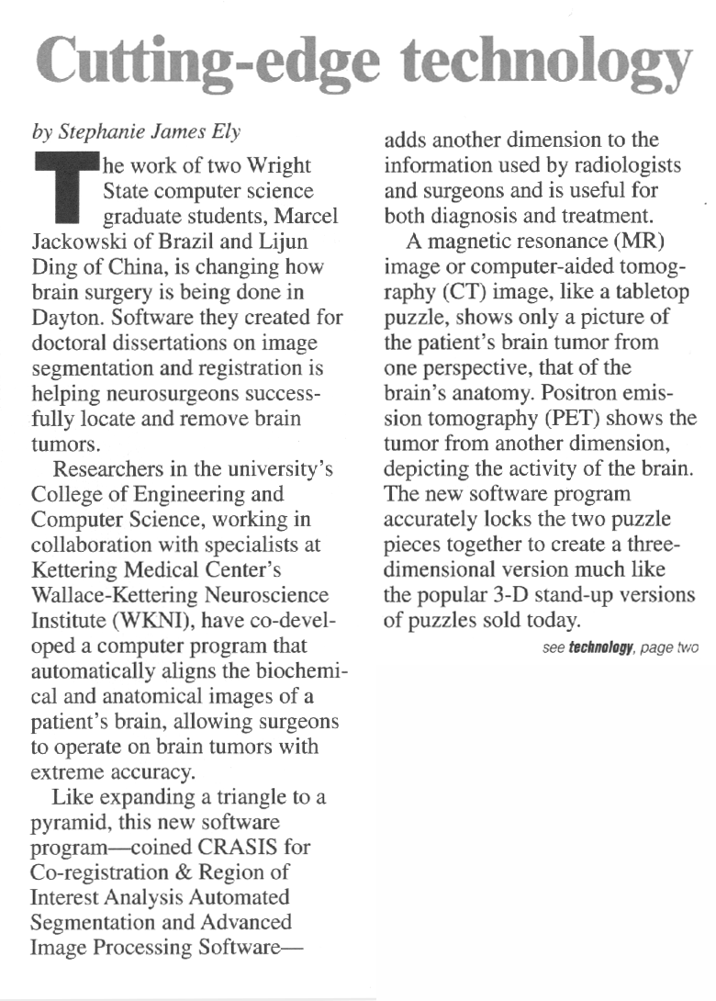

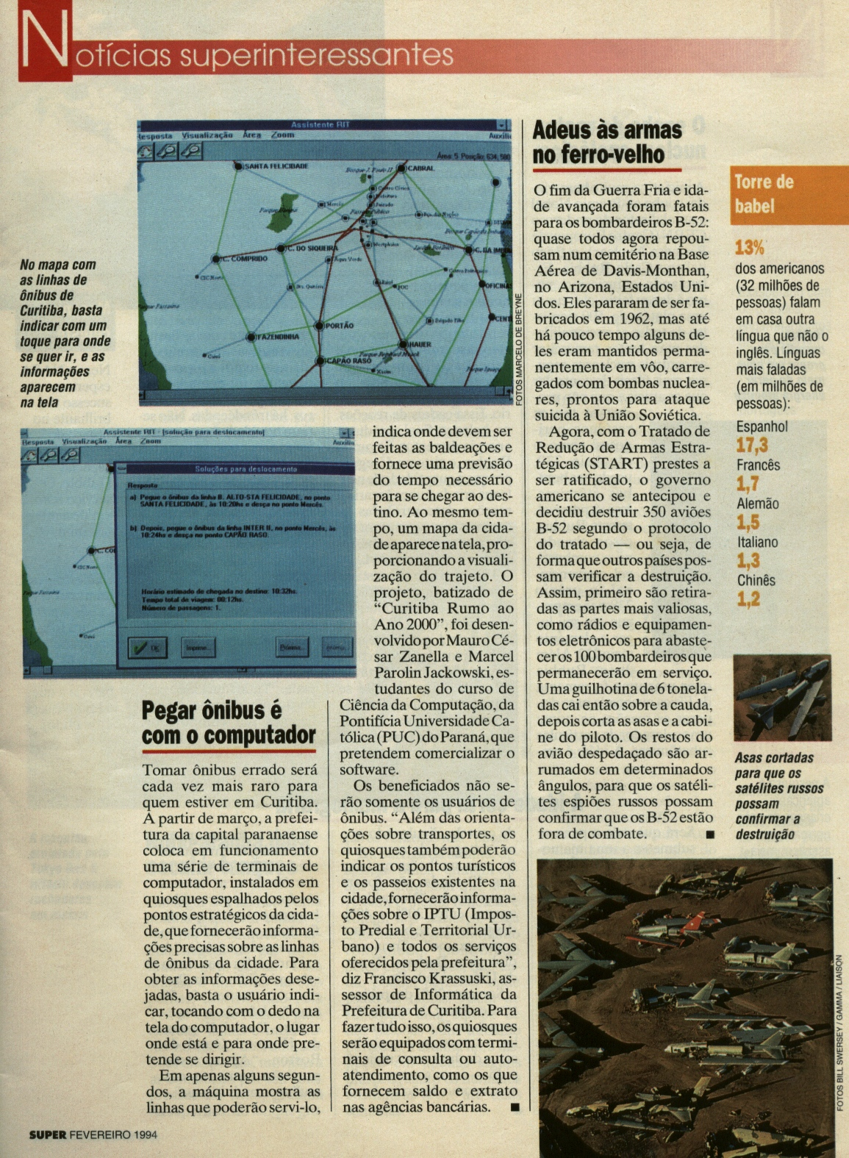

# ALNUMER Documentos 5.5

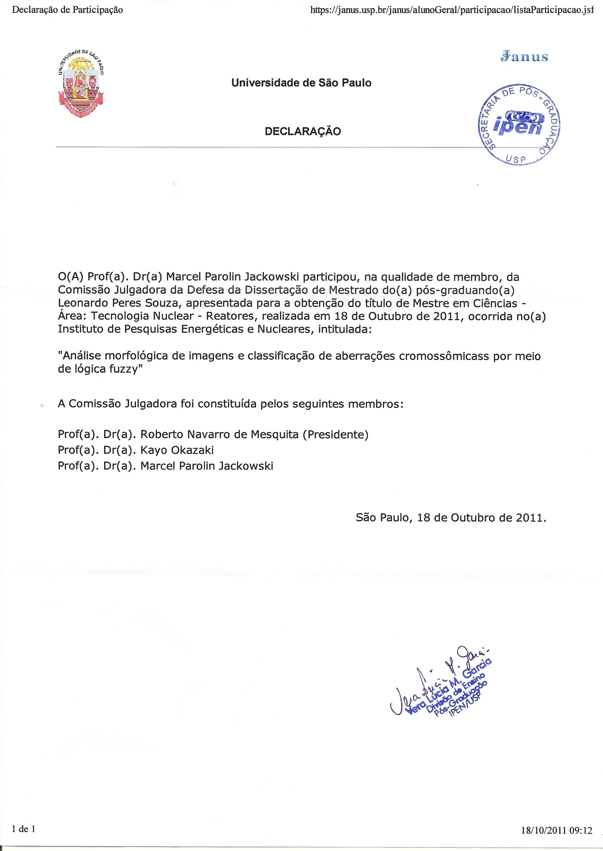

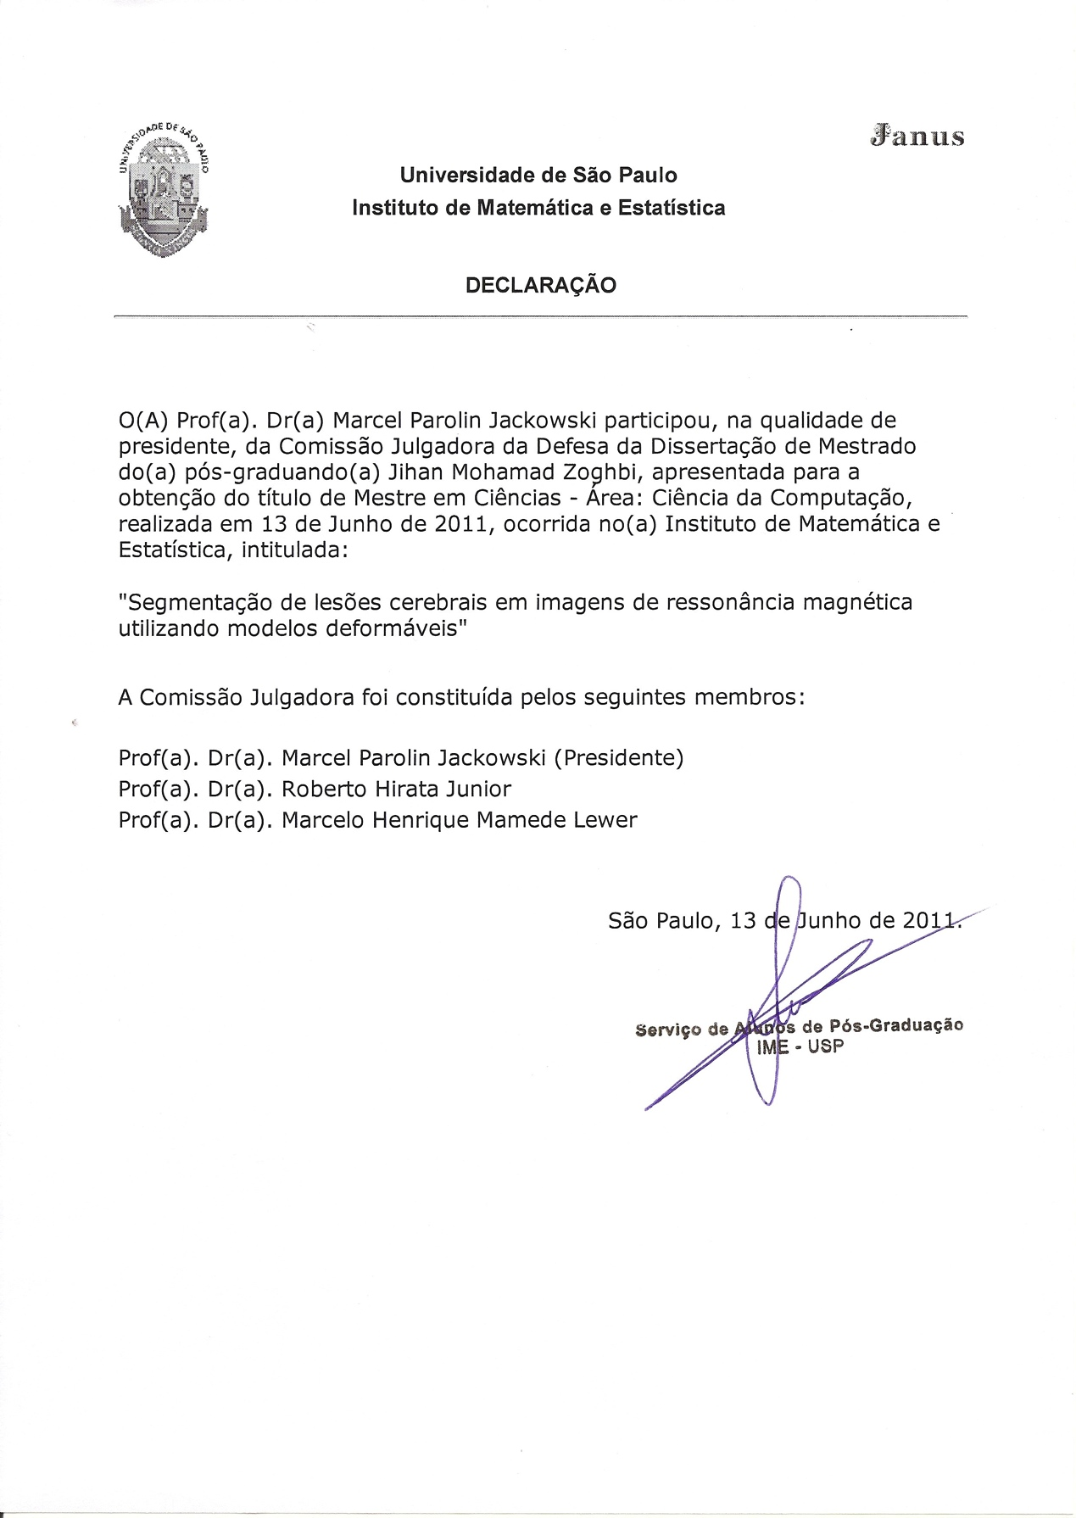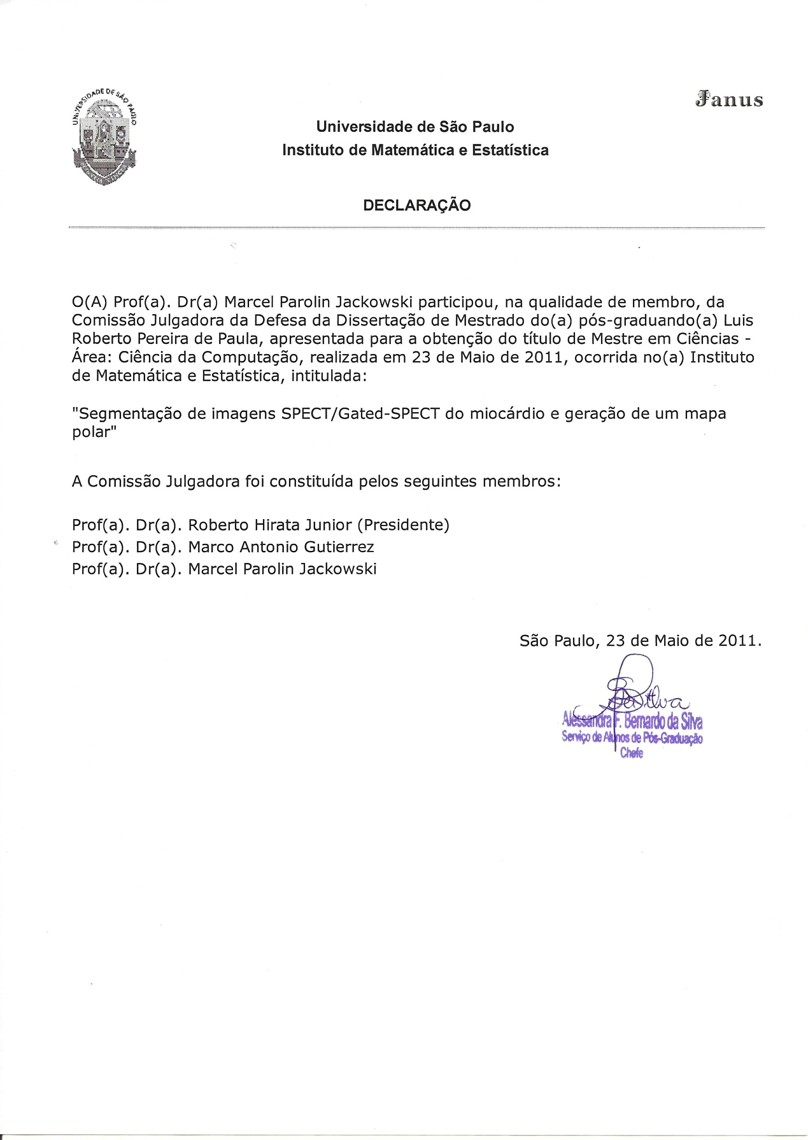

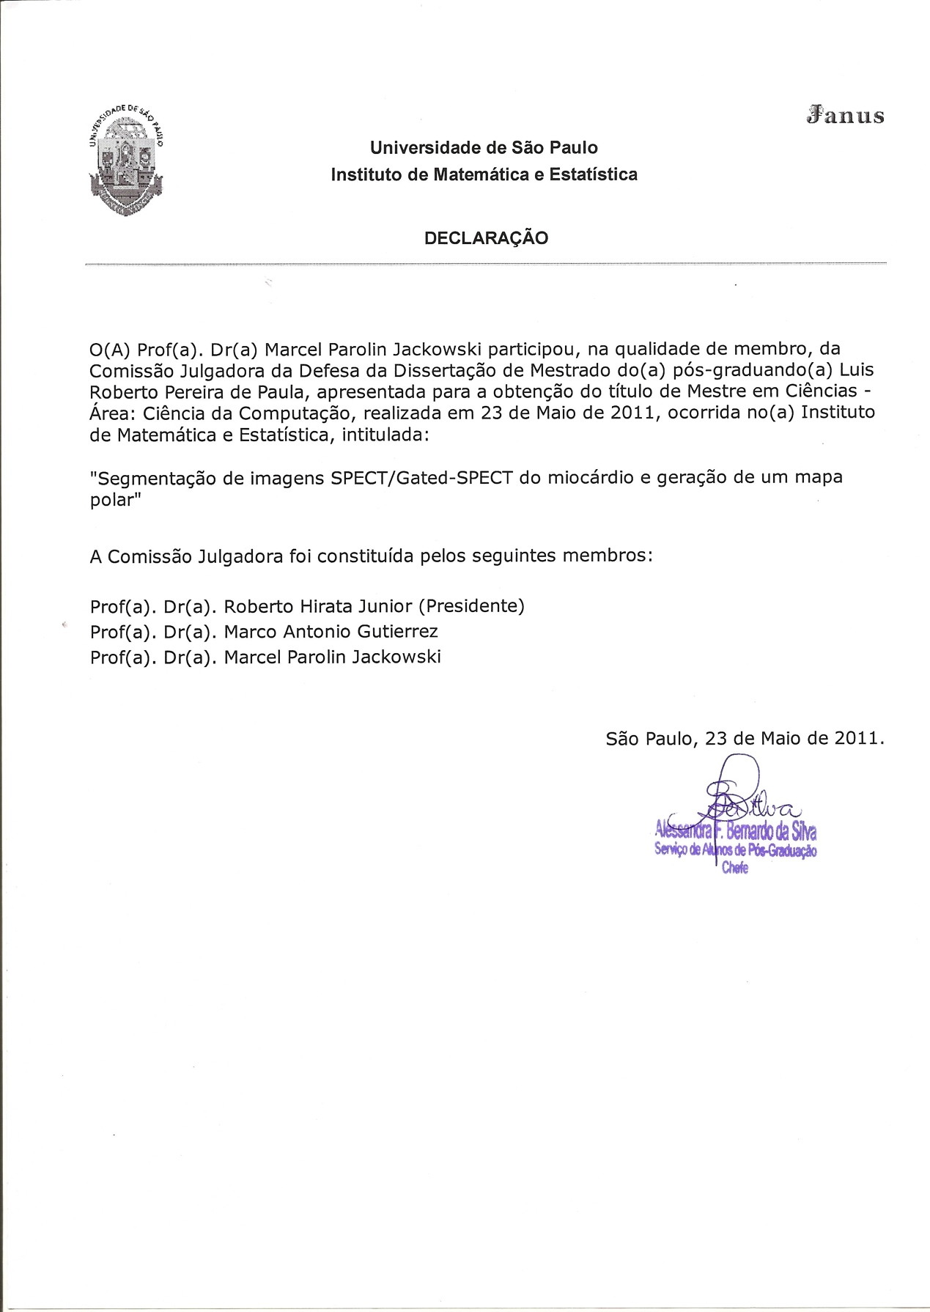

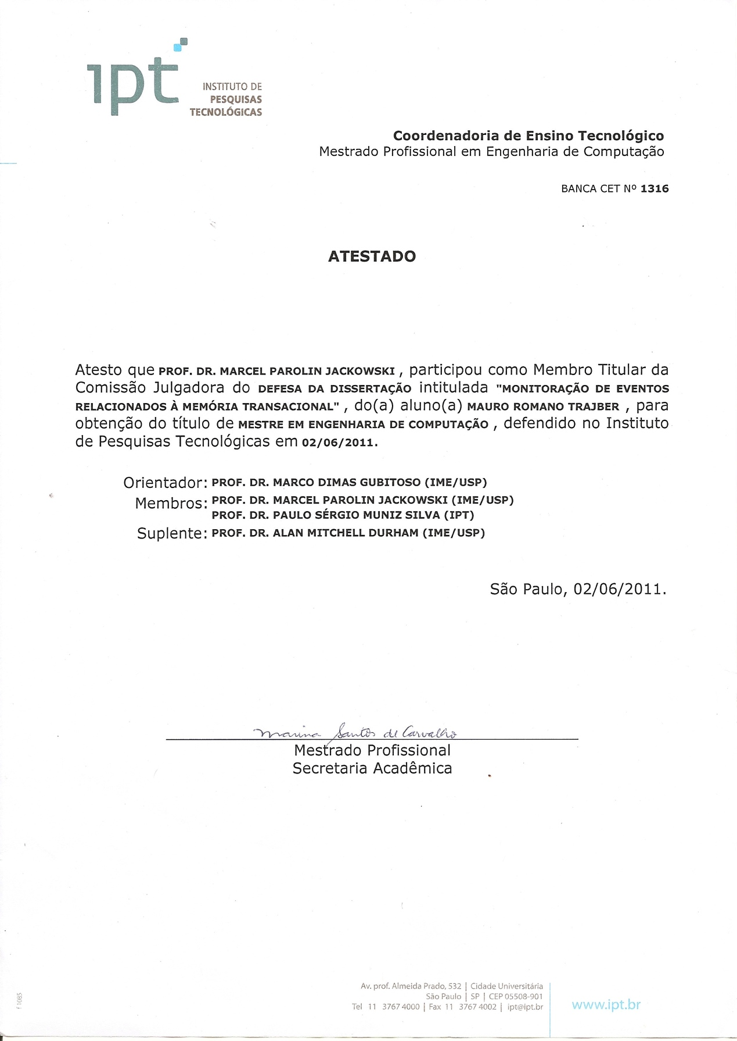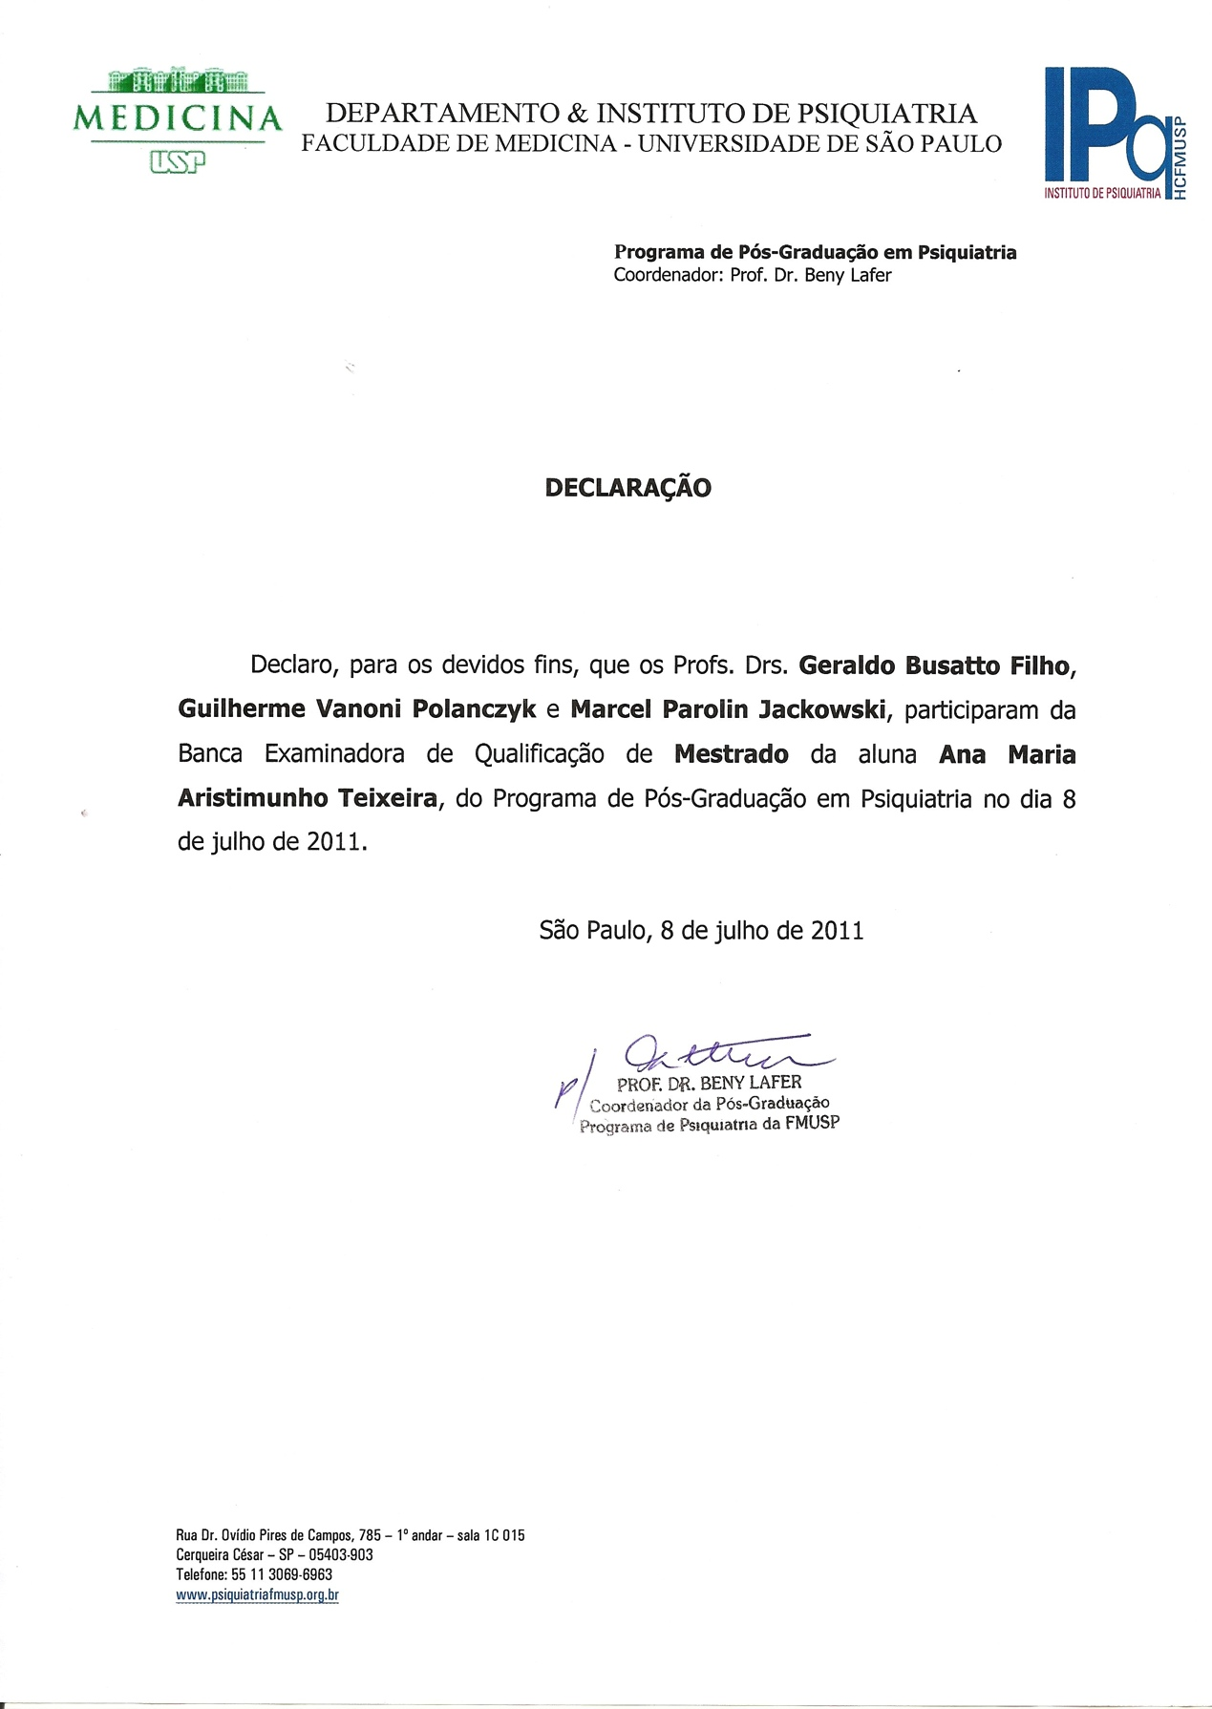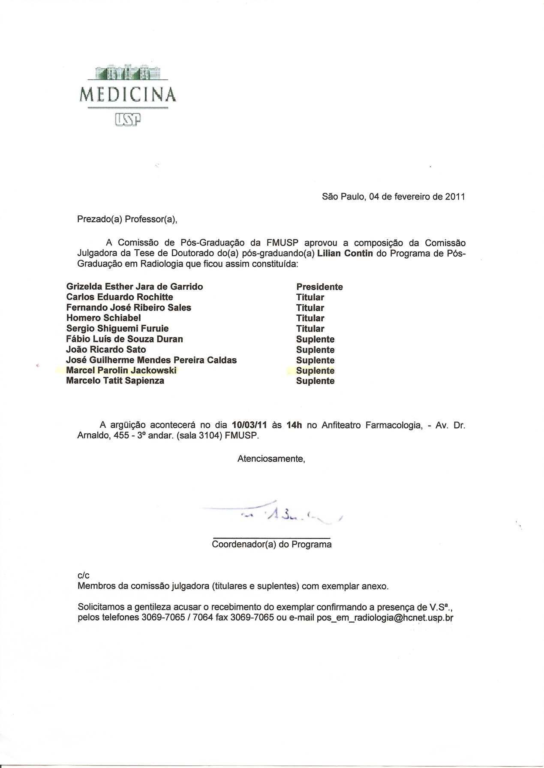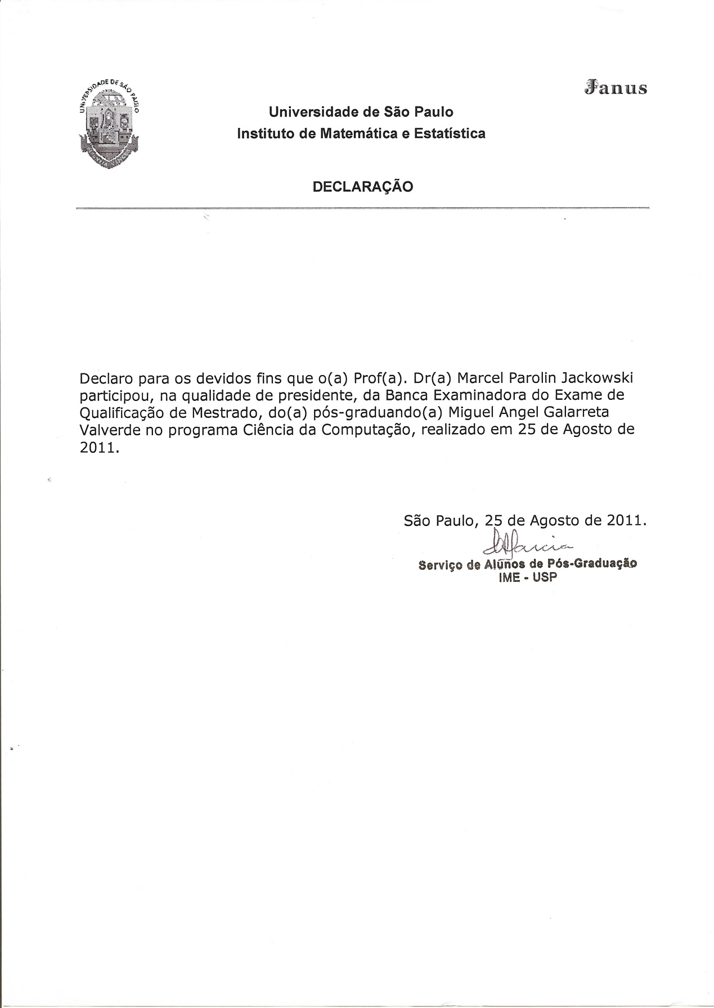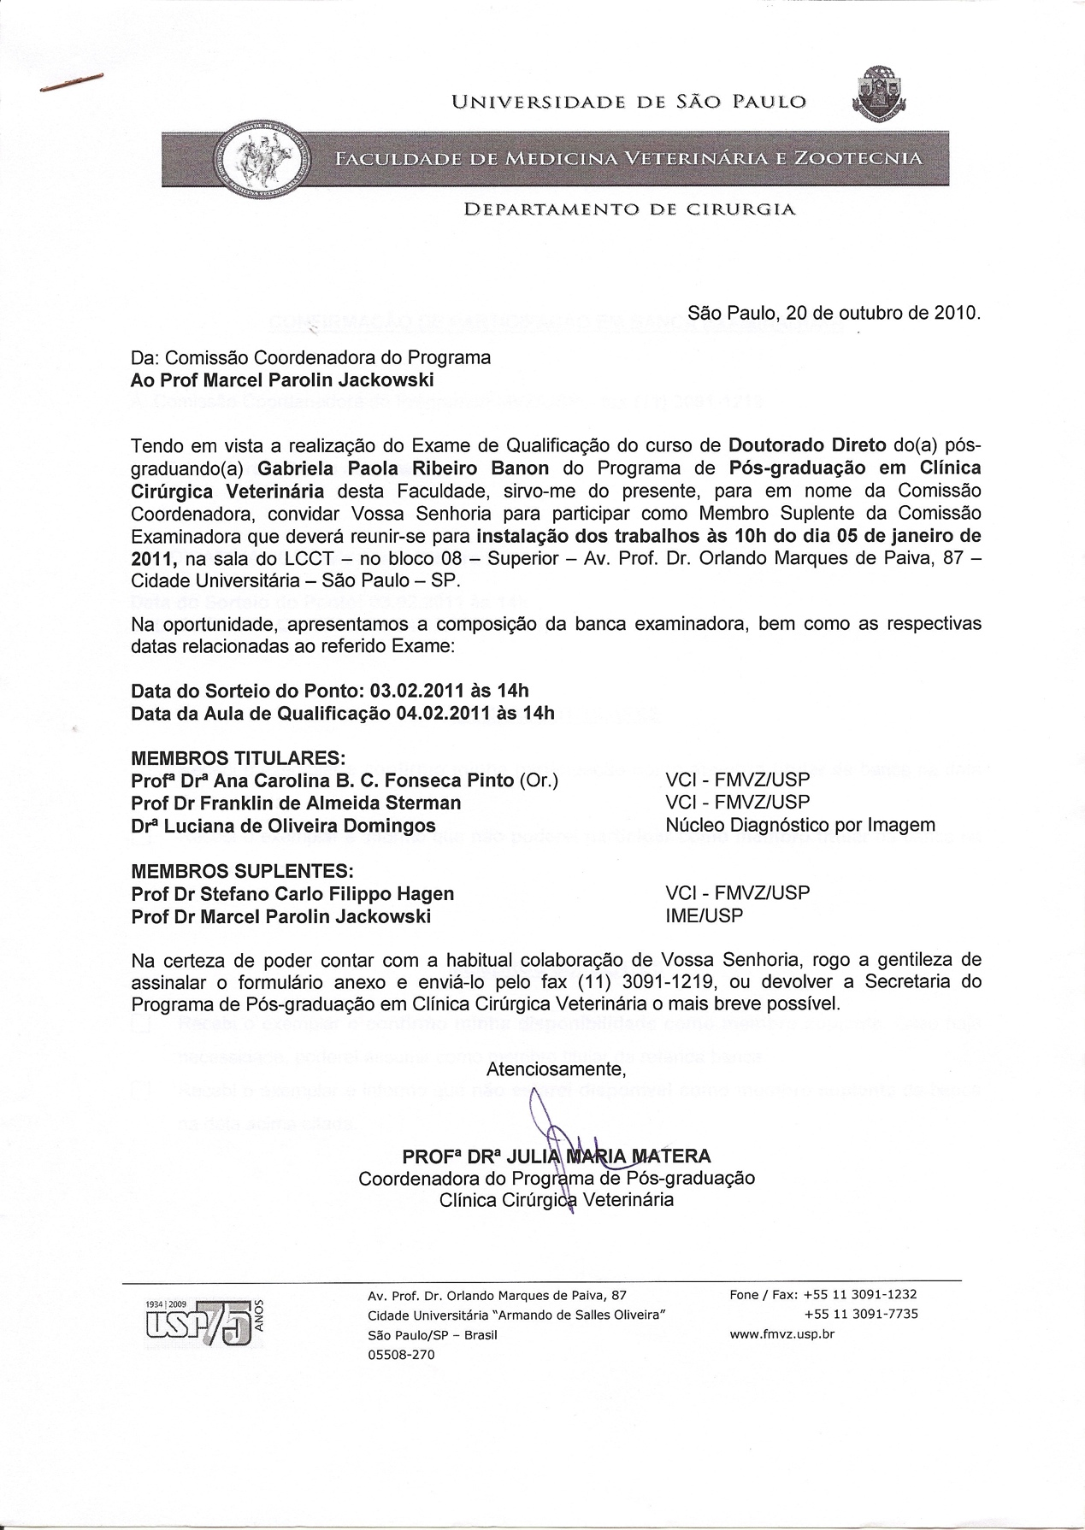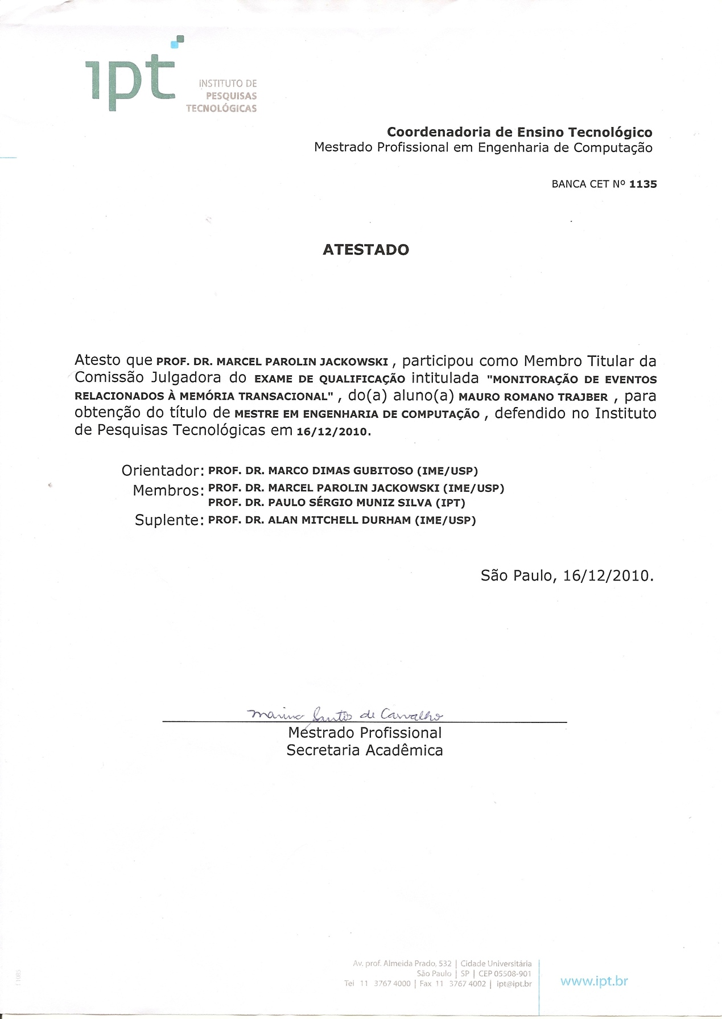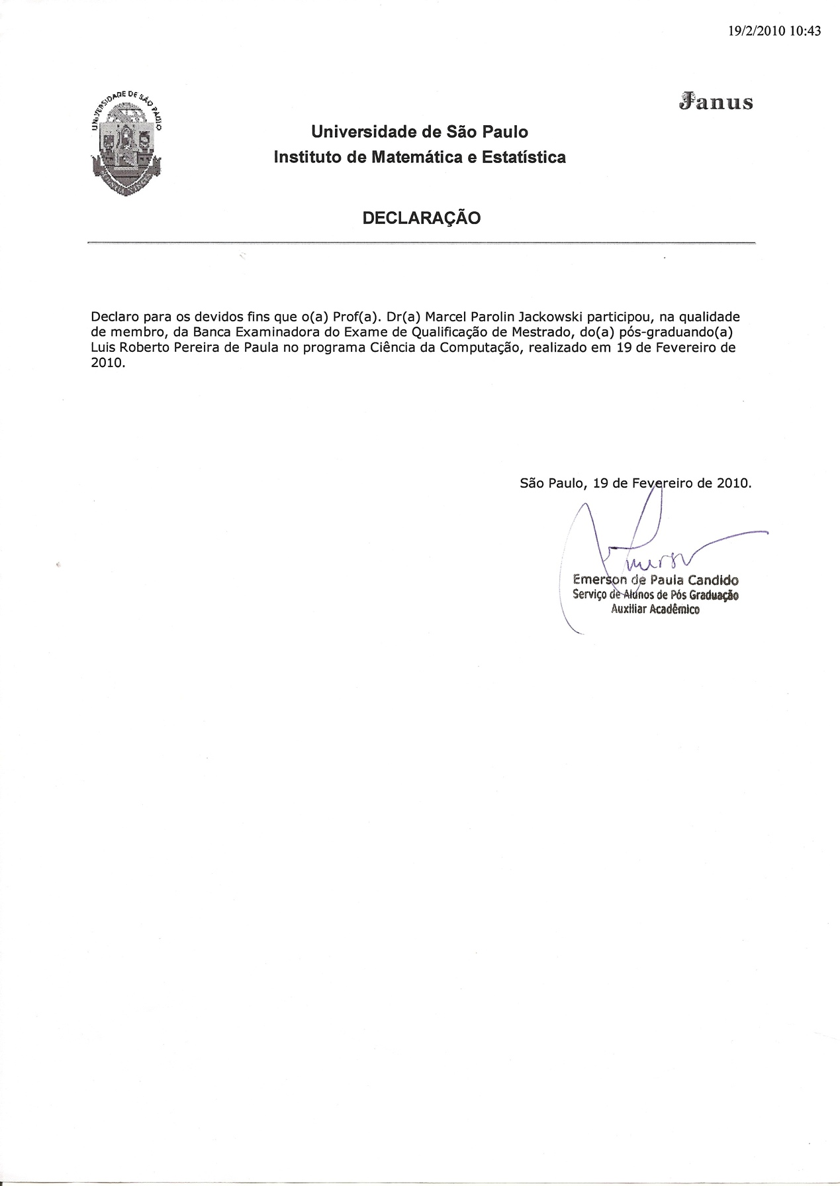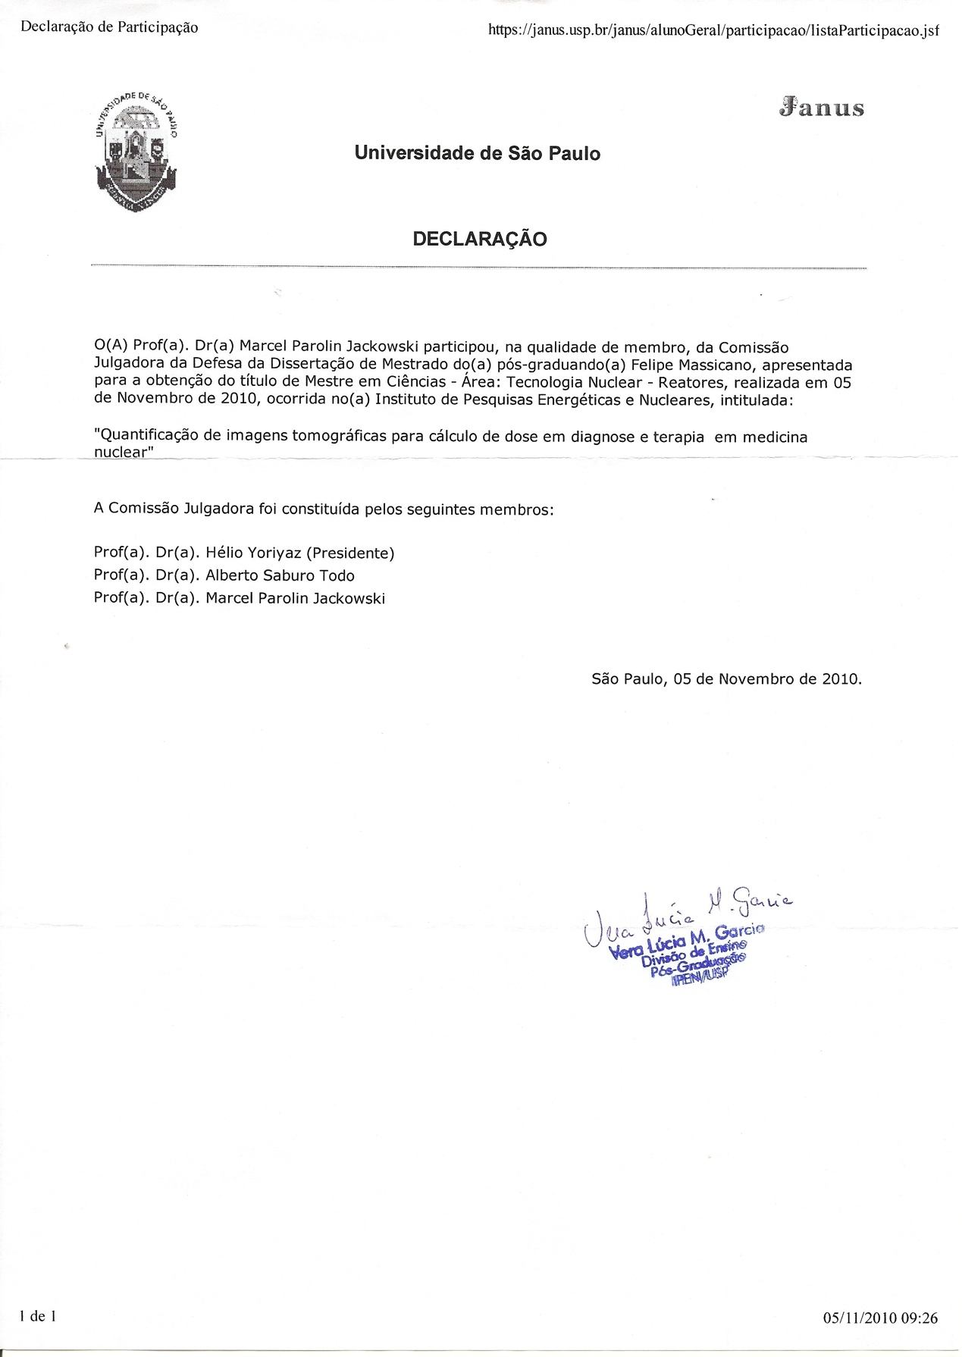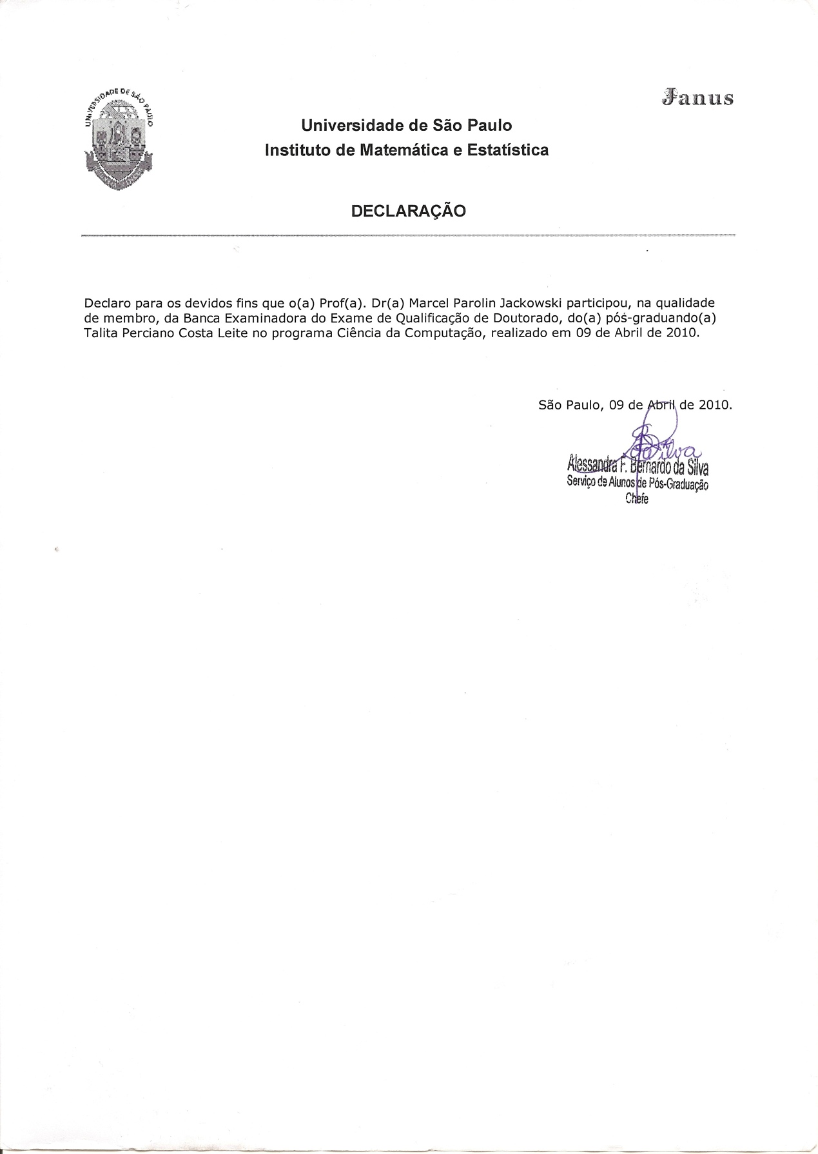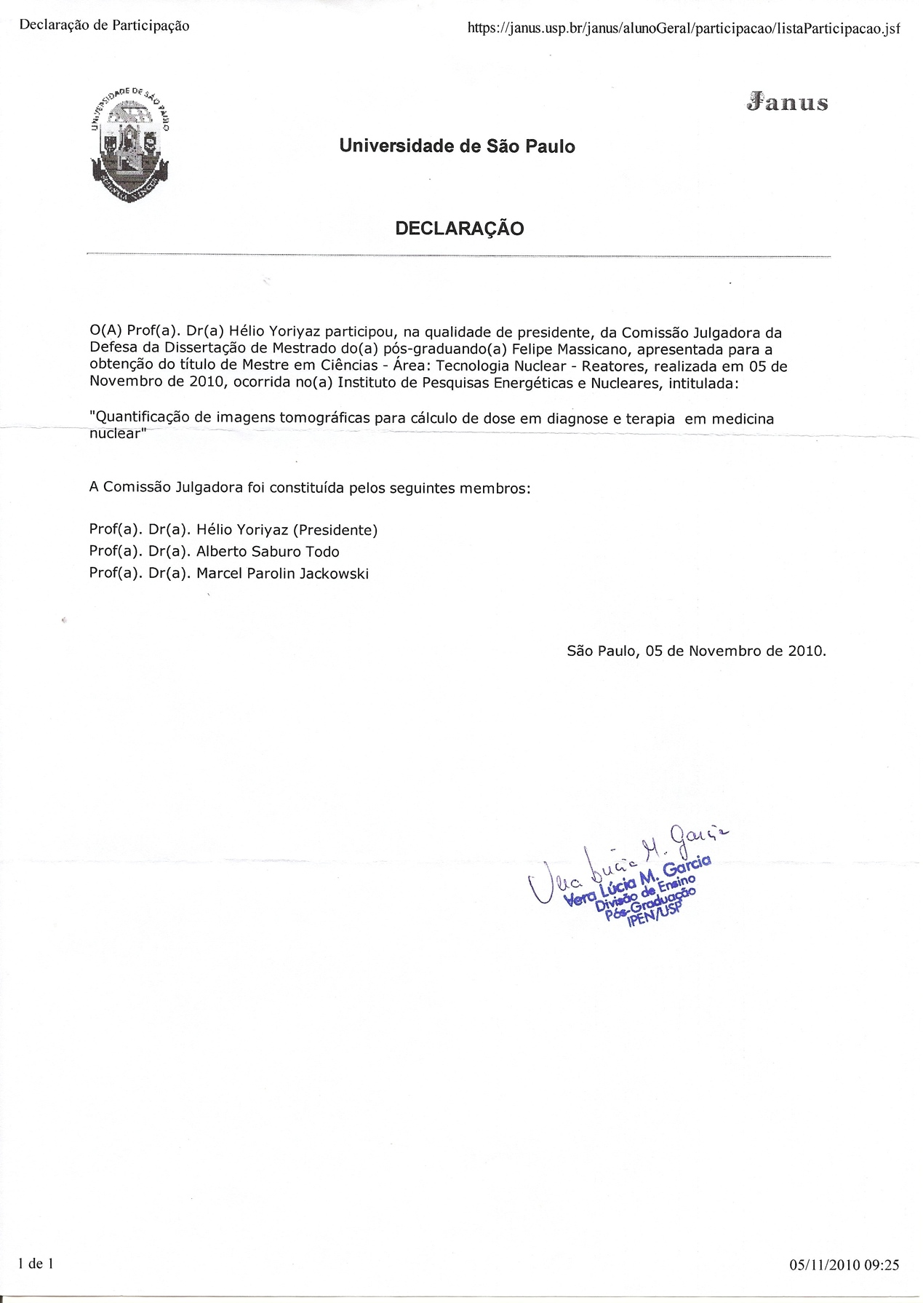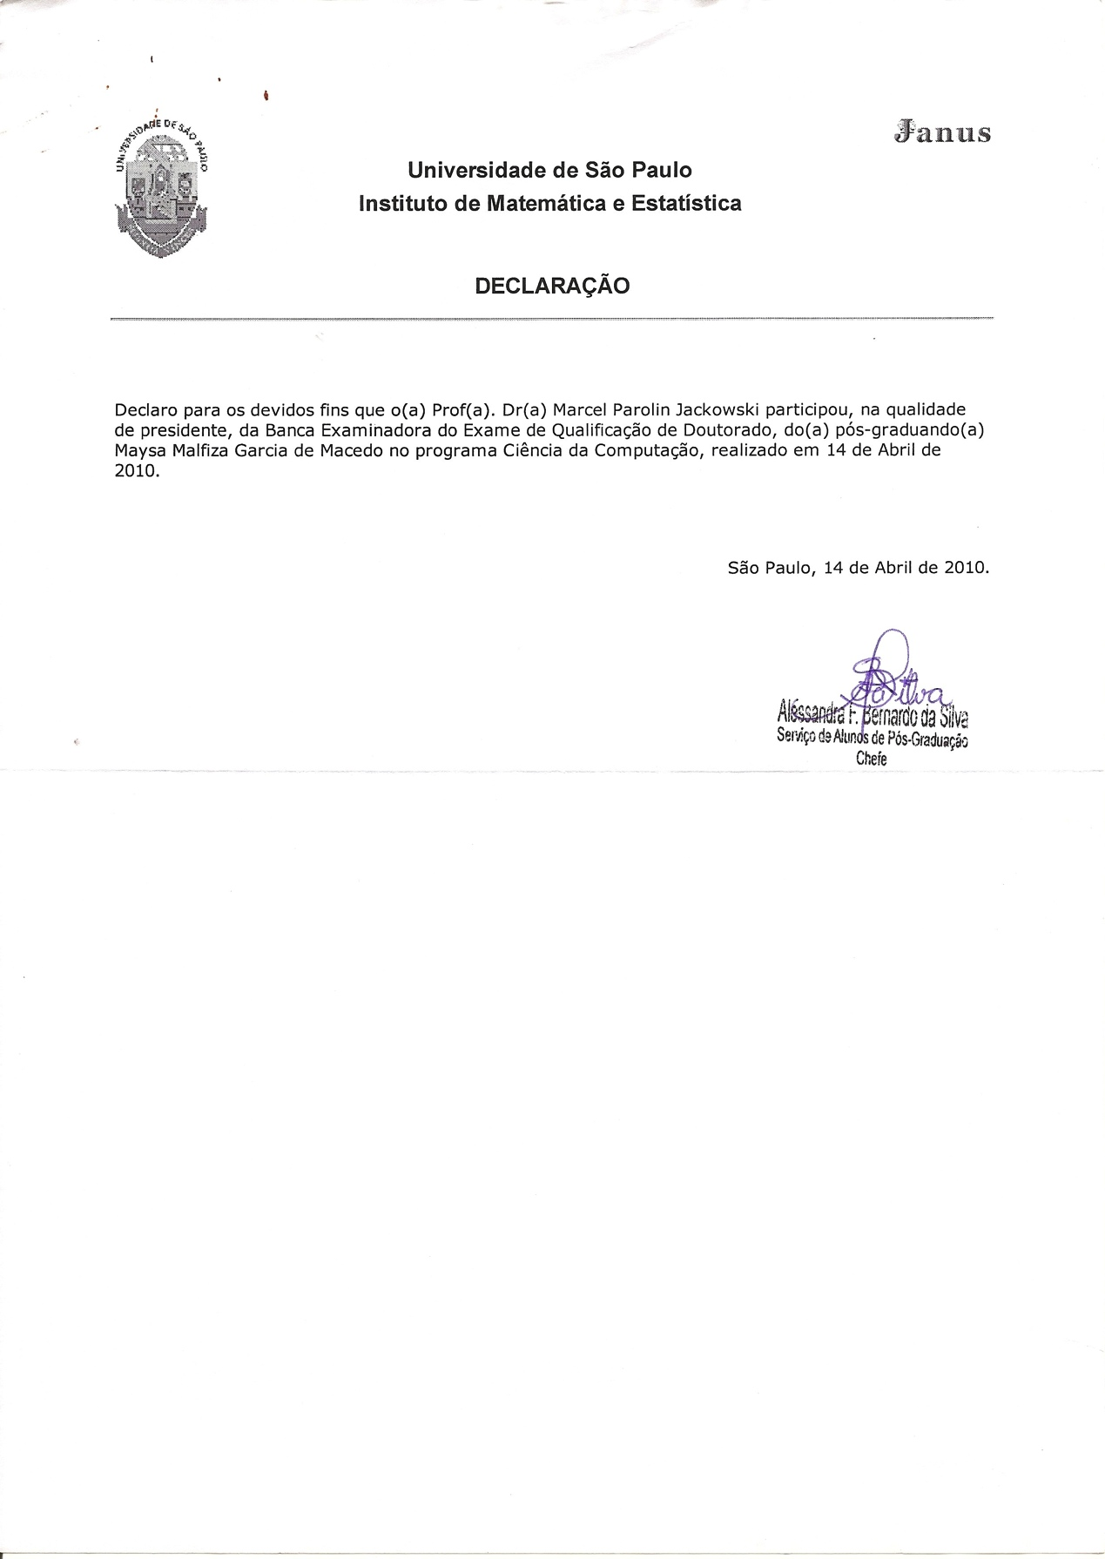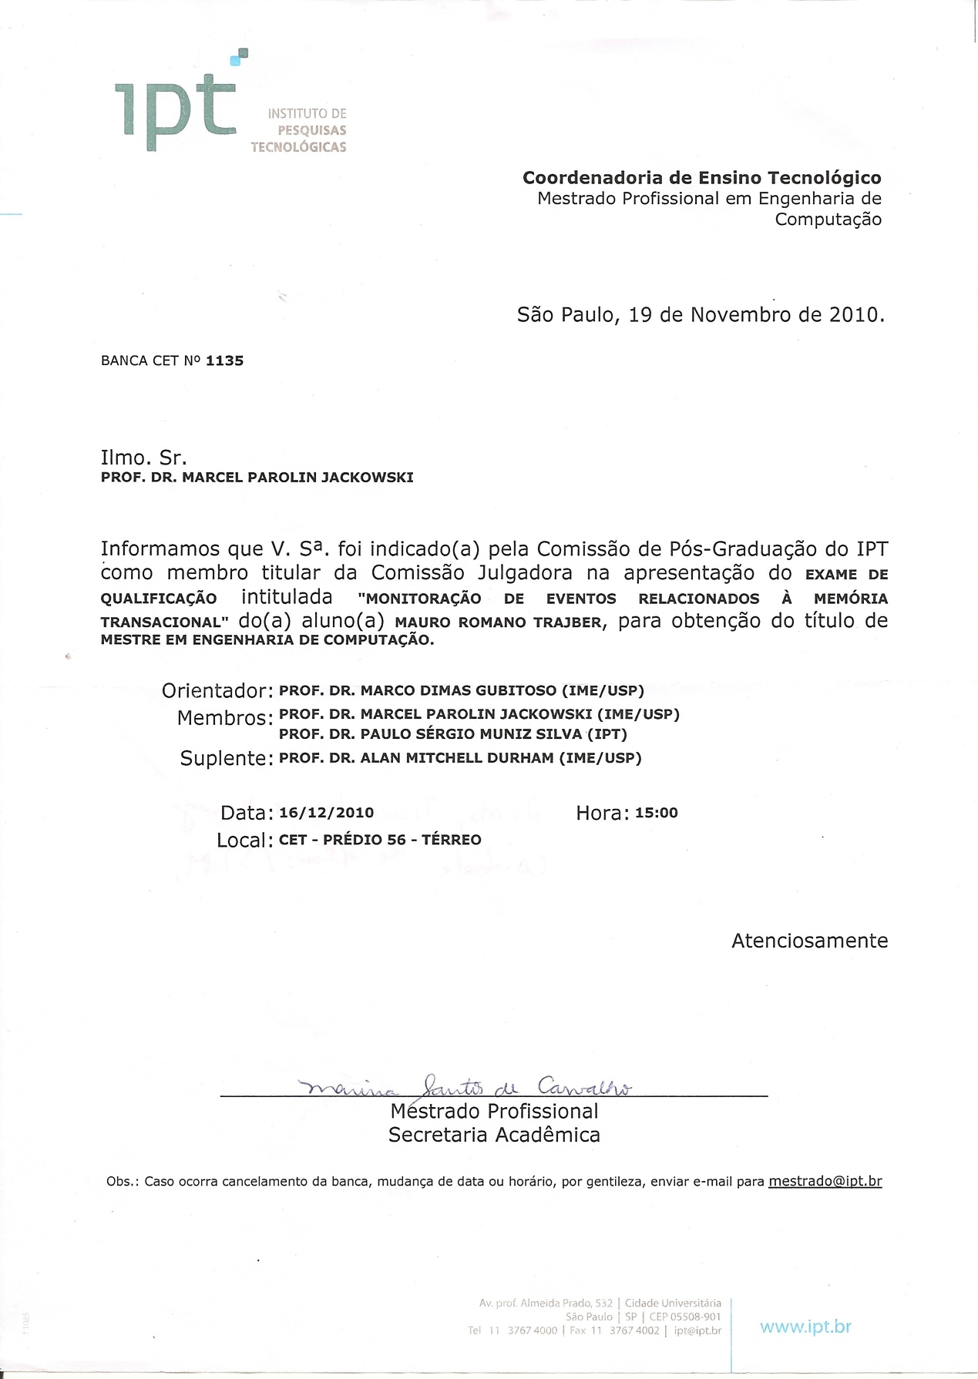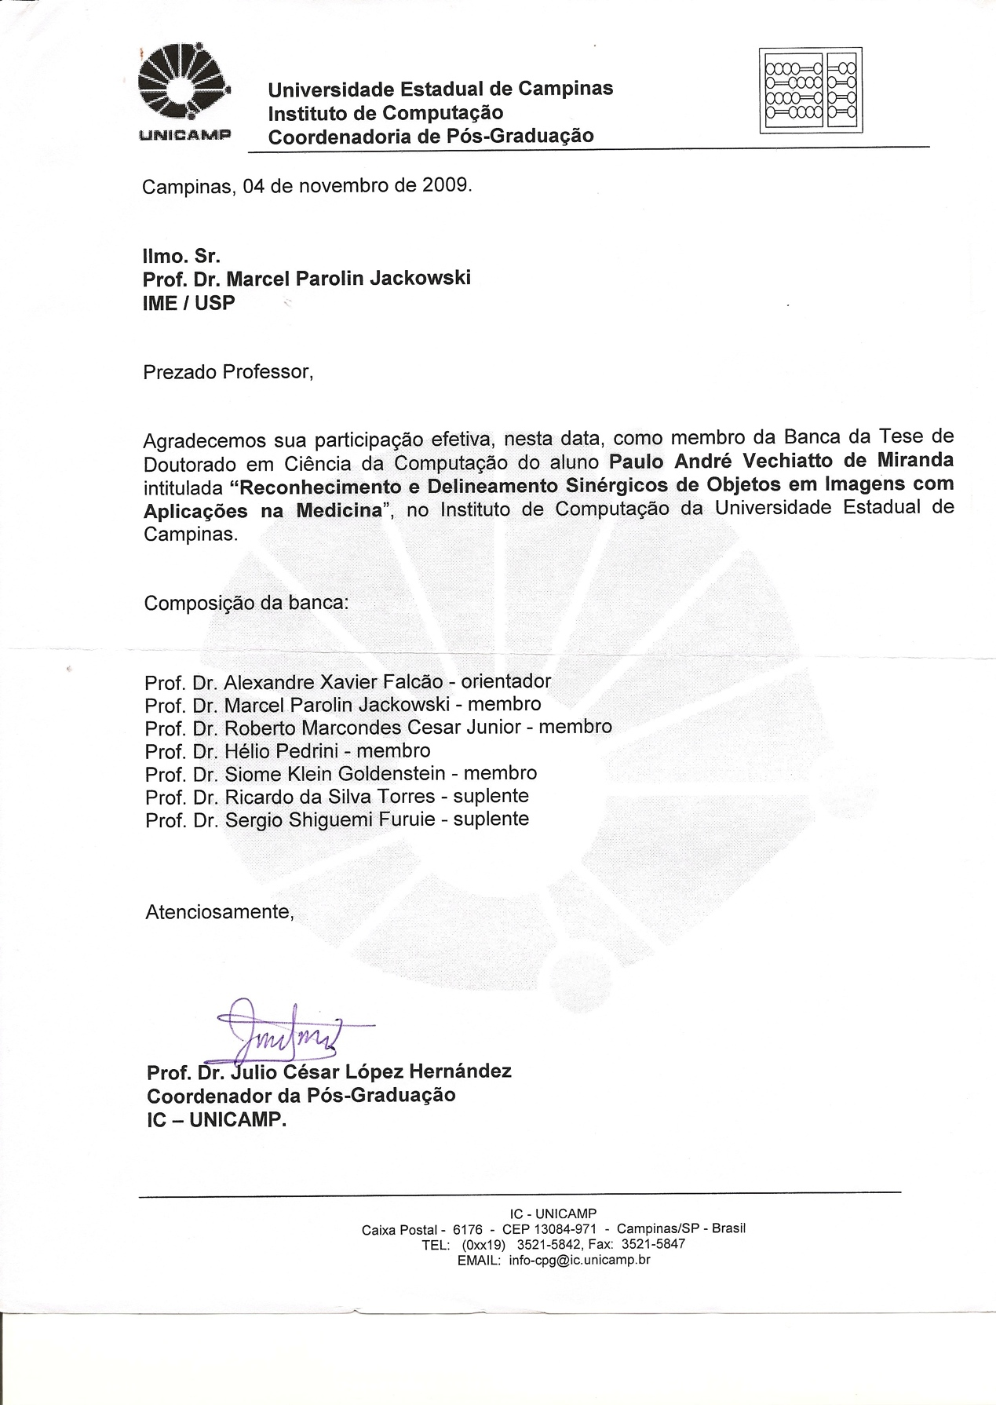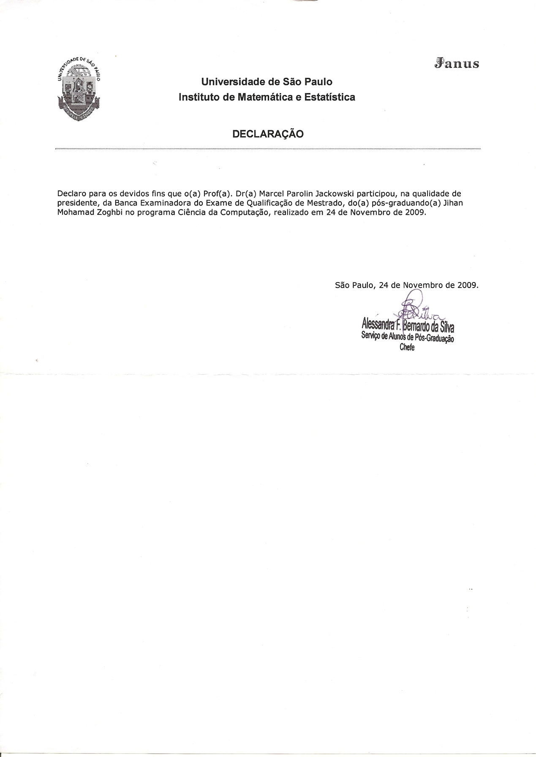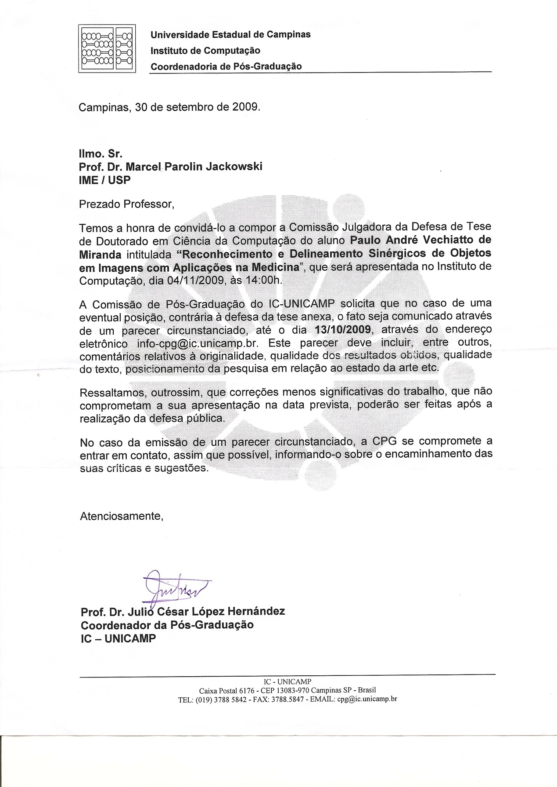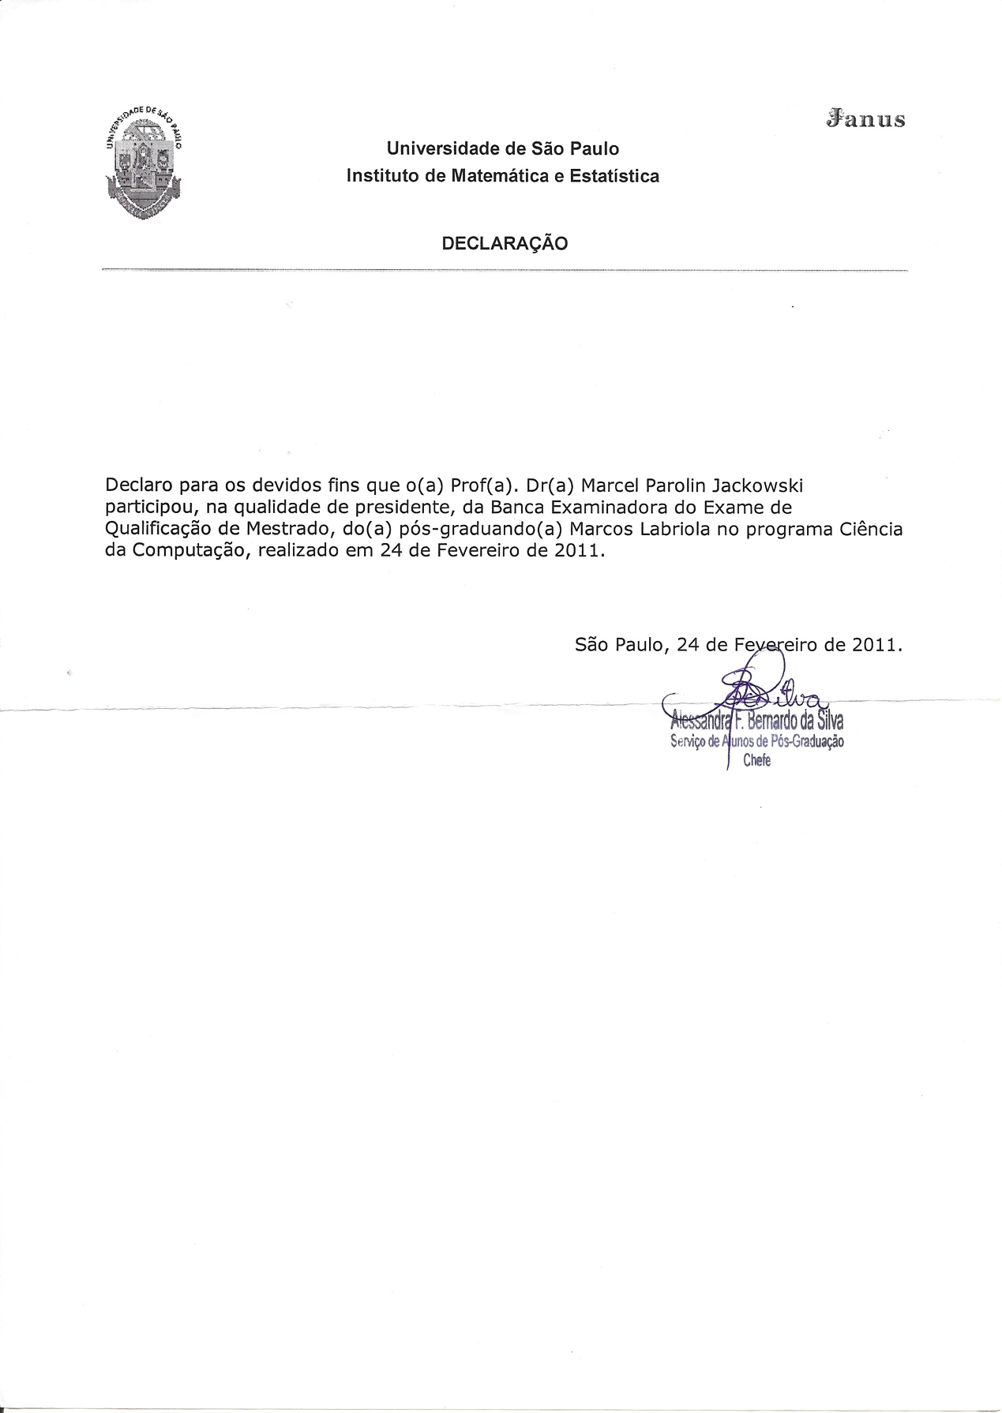

# Documentos 6.1.1

**Macintosh HD:Users:mjack:Documents:Memorial:Aulas-2006-2.pdf**

**Macintosh HD:Users:mjack:Documents:Memorial:Aulas-2007-1.pdf**

**Macintosh HD:Users:mjack:Documents:Memorial:Aulas-2007-2.pdf**

Macintosh HD:Users:mjack:Documents:Memorial:Aulas-2008-1.pdf

Macintosh HD:Users:mjack:Documents:Memorial:Aulas-2009-1.pdf

Macintosh HD:Users:mjack:Documents:Memorial:Aulas-2009-2.pdfMacintosh HD:Users:mjack:Documents:Memorial:Aulas-2010-2.pdfMacintosh HD:Users:mjack:Documents:Memorial:Aulas-2011-2.pdfMacintosh HD:Users:mjack:Documents:Memorial:Aulas-pos.pdf

# Documentos 6.3.1

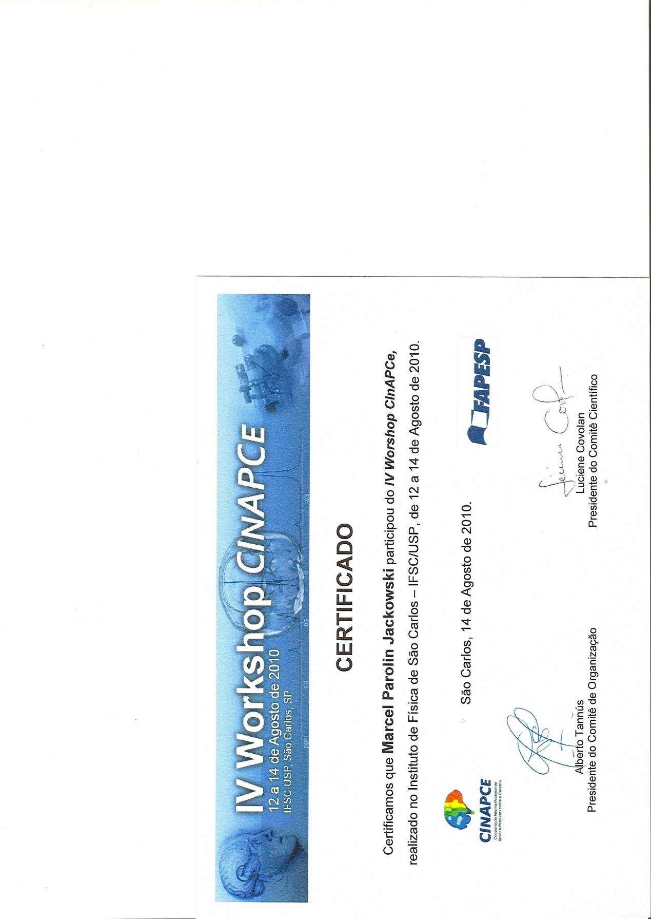

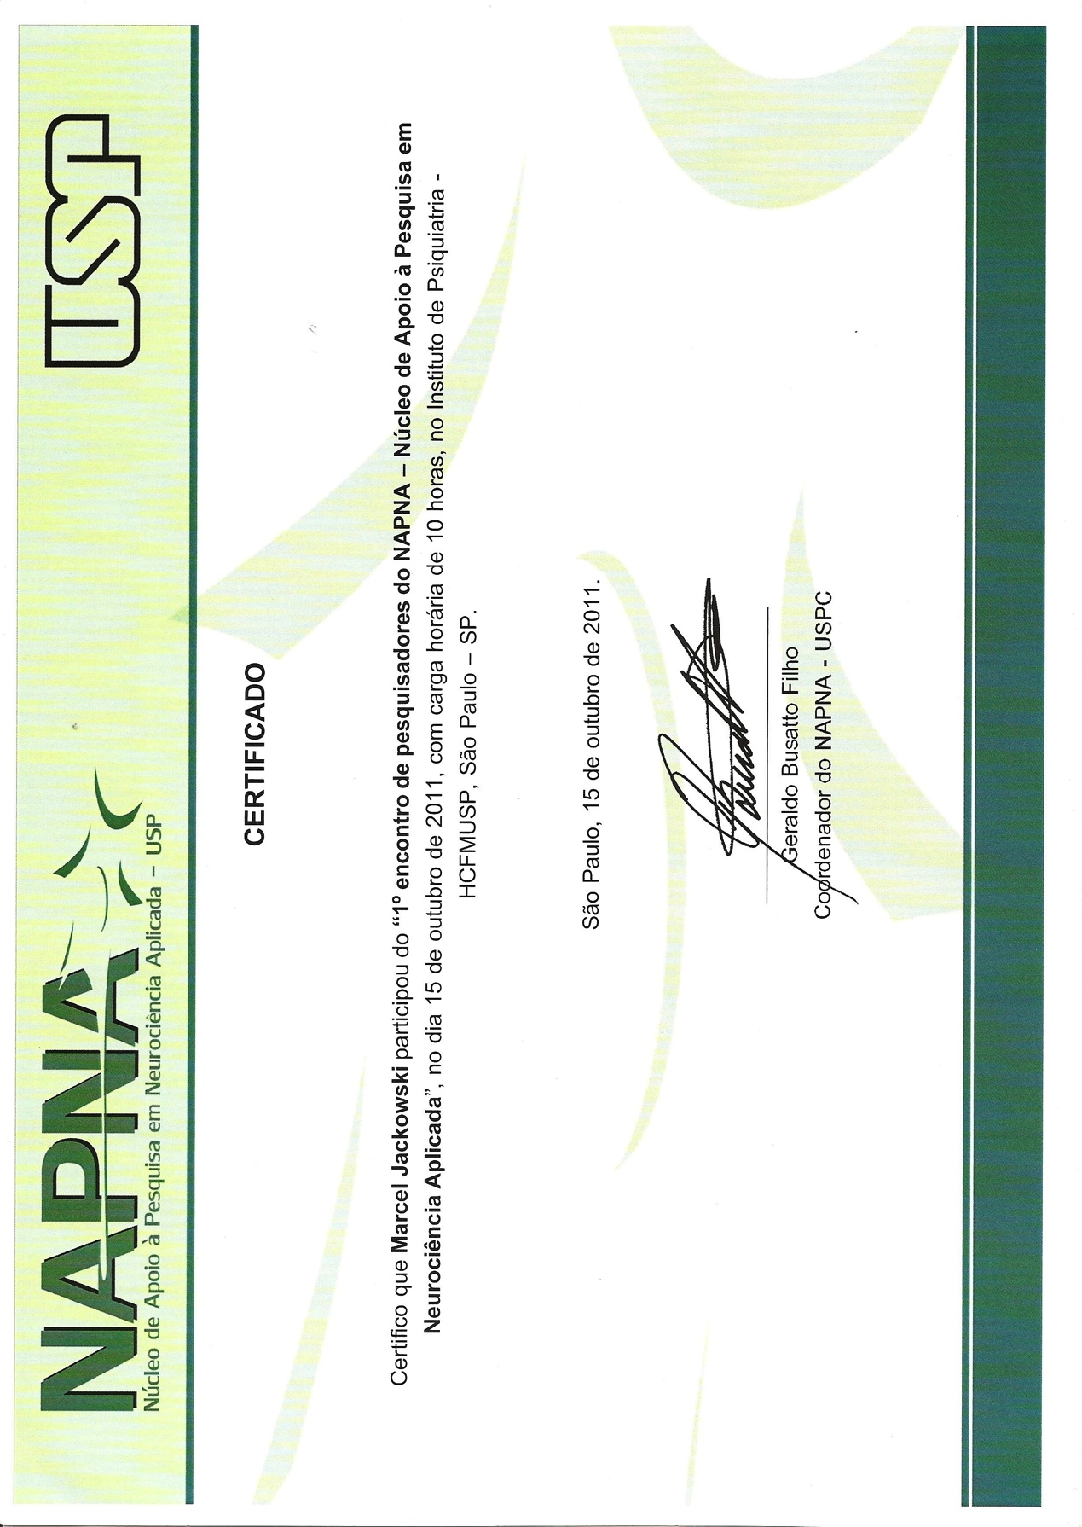

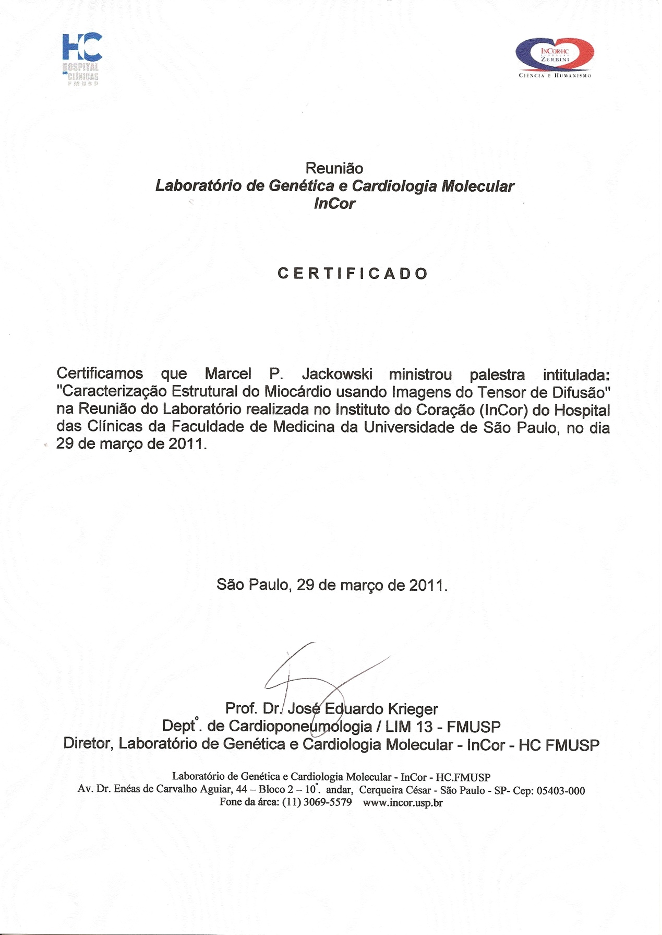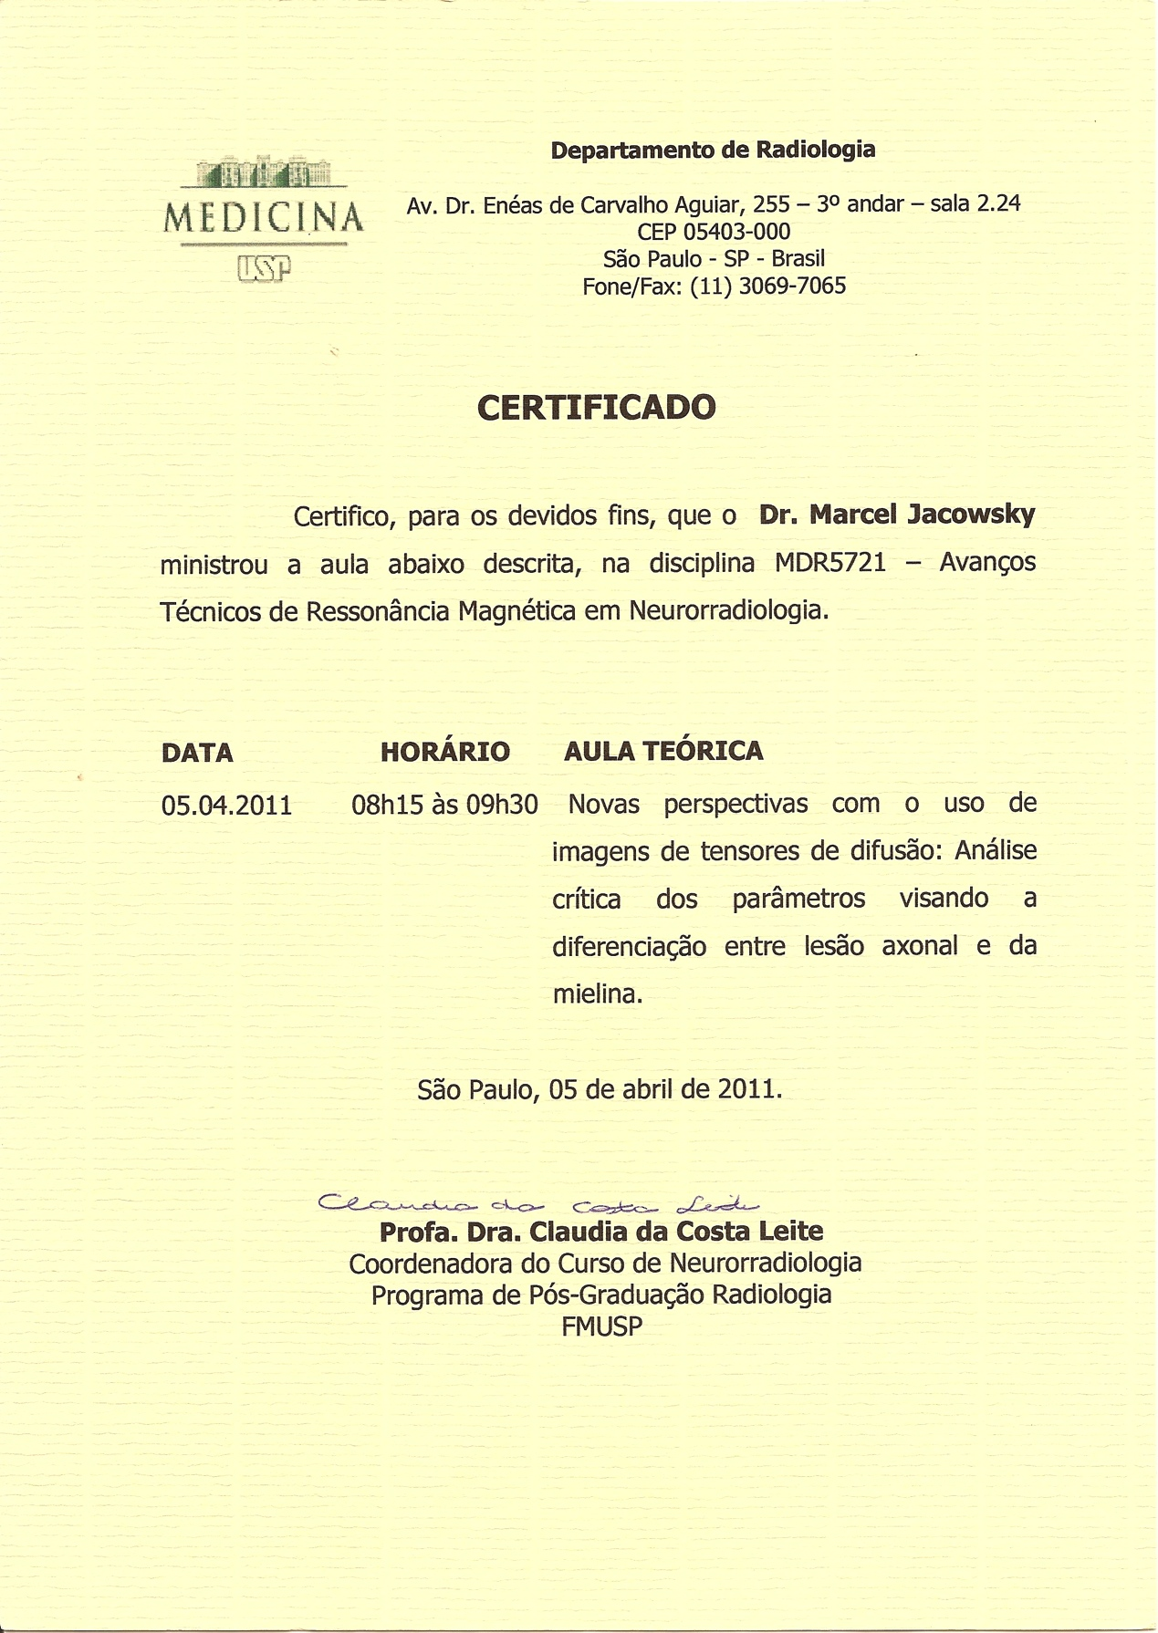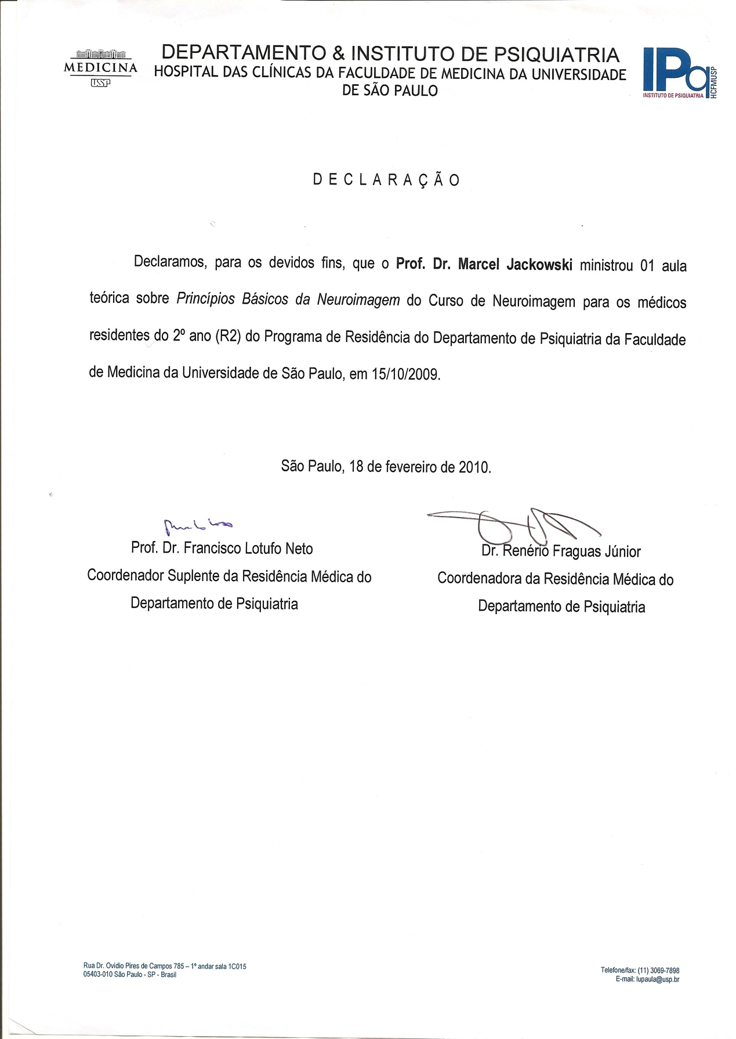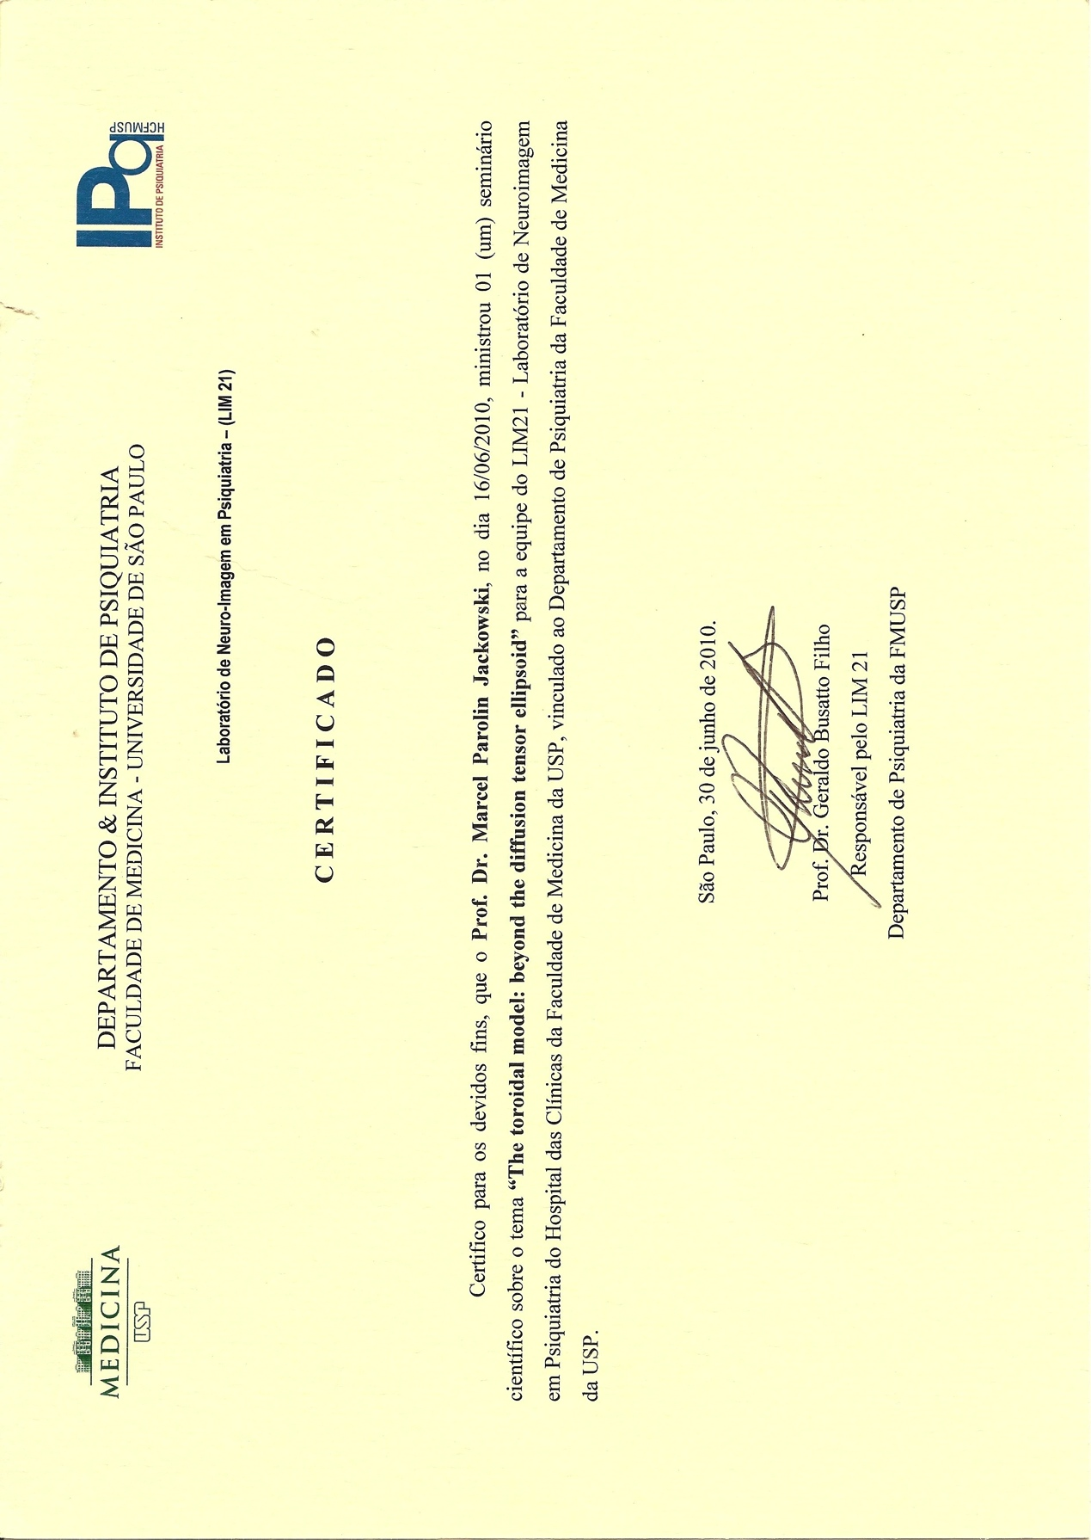

From gerig@miccai2005.org Fri Jul 8 16:42:56 2005

Date: Mon, 04 Jul 2005 18:22:31 -0400

From: gerig@miccai2005.org

To: mjack@noodle.med.yale.edu

Cc: gerig@miccai2005.org

Subject: MICCAI 2005 notification - #166

Dear Marcel Jackowski -

The paper selection procedure for MICCAI 2005 has now been completed. We are pleased to let you know that your paper

166 - A Computer-Aided Design System for Revision of Segmentation Errors

has been selected for POSTER presentation at MICCAI 2005 in Palm Springs, California. The final program will be posted within the coming weeks on our web-site http://www.miccai2005.org/, but please be aware that posters will be presented during an afternoon session on one of the three days. Your poster should be arranged in portrait style, approximately 36 inches wide by 48 inches long.

In addition, on the day of your presentation, we will ask you to present a 1 minute poster "teaser" just before the lunch break. For this, please prepare 1 powerpoint slide that we will ask you for ahead of time. This slide should be brief, showing only the title of your poster and a few brief words and pictures illustrating the basic idea of the work.

We have sent out the notification of acceptance earlier but you can login to https://precisionconference.com/~miccai05/ and look up your reviews (click at submissions in progress).

In total we received 632 full paper and 34 short paper submissions. Out of the 632 full papers, 239 were accepted (46 podium and 193 poster presentations).

STUDENT AWARDS: Students(first authors of work not carried out after PhD) are eligible for the attractive MICCAI student awards (see http://www.ia.unc.edu/MICCAI2005/MICCAI2005awards.html). Please send email to Delphine Bull (bull@cs.unc.edu) with copy of this message if you are eligible and have not yet replied.

Accepted full papers will get 8 pages in the proceedings. The format of your final submission is defined in the submission guidlines (www.miccai2005.org -> Papers) and you will have to strictly adhere to the formatting rules of the Springer LNCS format. We will send out detailed information in regard to material to be submitted later, deadline is July 20th 2005.

We look forward to seeing you in Palm Springs,

Sincerely,

Guido Gerig and Jim Duncan

gerig@miccai2005.org

http://www.miccai2005.org/

From gerig@miccai2005.org Fri Jul 8 16:43:13 2005

Date: Mon, 04 Jul 2005 18:23:36 -0400

From: gerig@miccai2005.org

To: mjack@noodle.med.yale.edu

Cc: gerig@miccai2005.org

Subject: MICCAI 2005 notification - #907

Dear Marcel Jackowski -

The paper selection procedure for MICCAI 2005 has now been completed. We are pleased to let you know that your paper

907 - Characterizing Vascular Connectivity from microCT Images

has been selected for POSTER presentation at MICCAI 2005 in Palm Springs, California. The final program will be posted within the coming weeks on our web-site http://www.miccai2005.org/, but please be aware that posters will be presented during an afternoon session on one of the three days. Your poster should be arranged in portrait style, approximately 36 inches wide by 48 inches long.

In addition, on the day of your presentation, we will ask you to present a 1 minute poster "teaser" just before the lunch break. For this, please prepare 1 powerpoint slide that we will ask you for ahead of time. This slide should be brief, showing only the title of your poster and a few brief words and pictures illustrating the basic idea of the work.

We have sent out the notification of acceptance earlier but you can login to https://precisionconference.com/~miccai05/ and look up your reviews (click at submissions in progress).

In total we received 632 full paper and 34 short paper submissions. Out of the 632 full papers, 239 were accepted (46 podium and 193 poster presentations).

STUDENT AWARDS: Students(first authors of work not carried out after PhD) are eligible for the attractive MICCAI student awards (see http://www.ia.unc.edu/MICCAI2005/MICCAI2005awards.html). Please send email to Delphine Bull (bull@cs.unc.edu) with copy of this message if you are eligible and have not yet replied.

Accepted full papers will get 8 pages in the proceedings. The format of your final submission is defined in the submission guidlines (www.miccai2005.org -> Papers) and you will have to strictly adhere to the formatting rules of the Springer LNCS format. We will send out detailed information in regard to material to be submitted later, deadline is July 20th 2005.

We look forward to seeing you in Palm Springs,

Sincerely,

Guido Gerig and Jim Duncan

gerig@miccai2005.org

http://www.miccai2005.org/

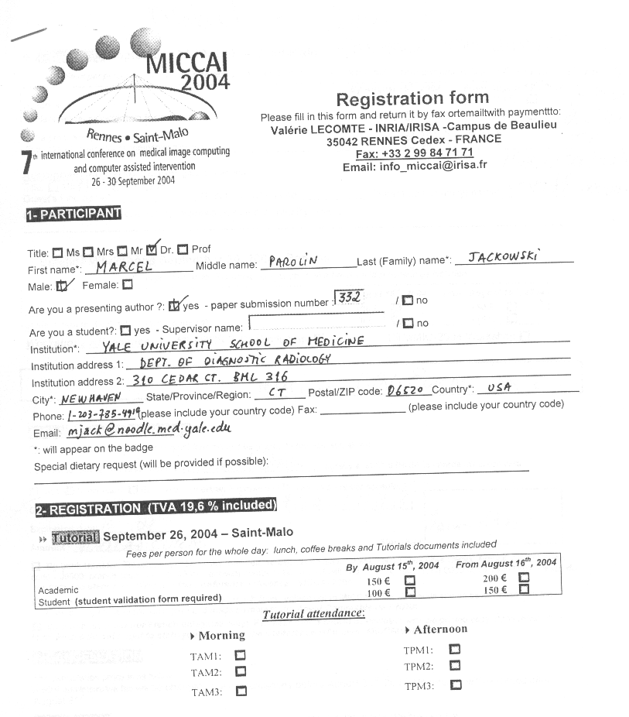

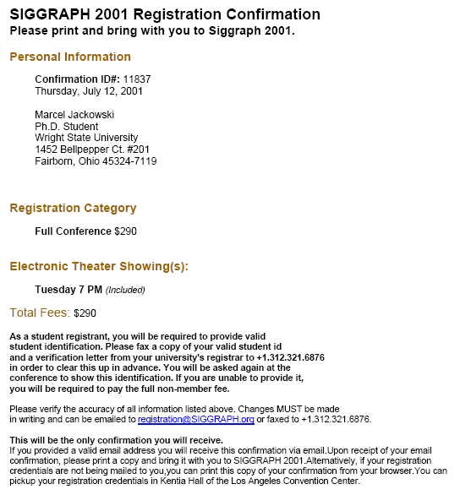

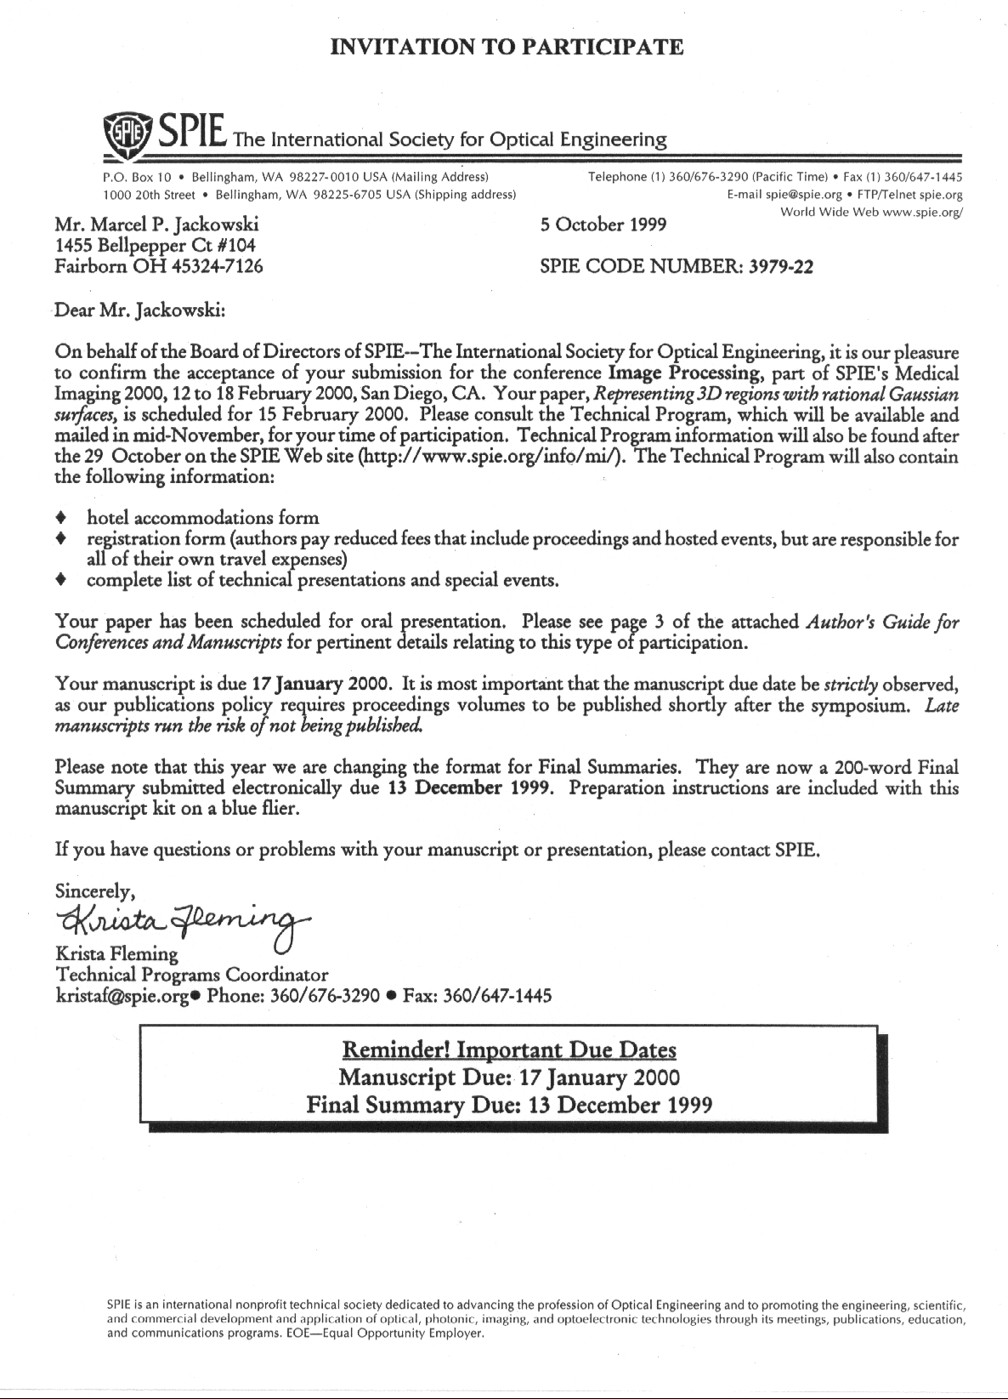

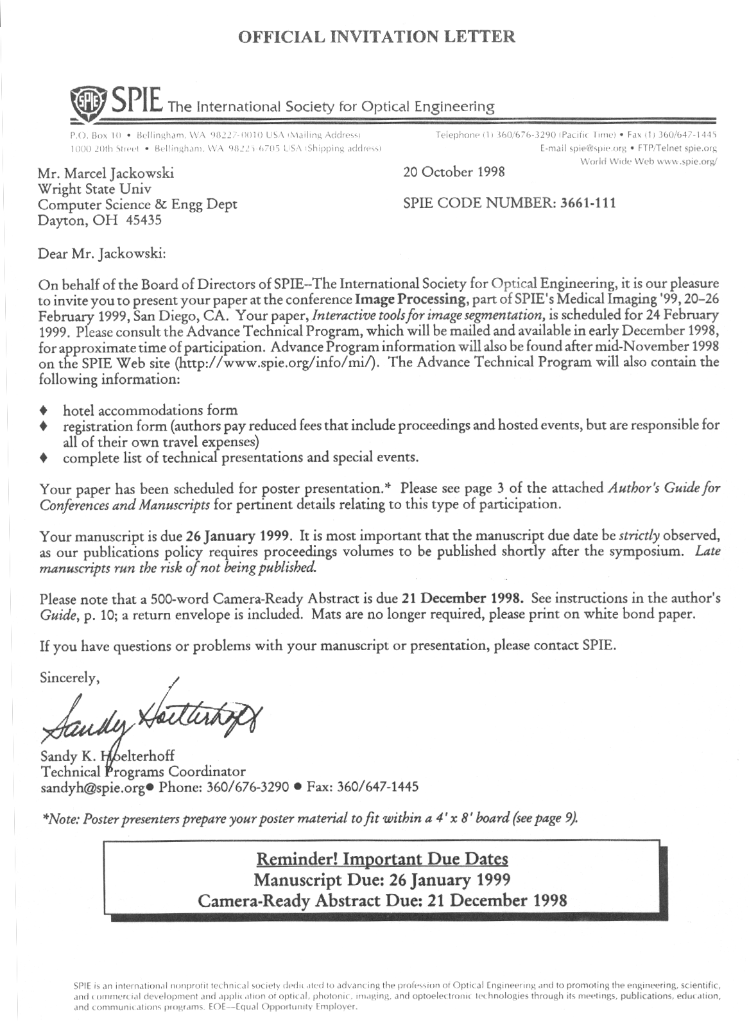

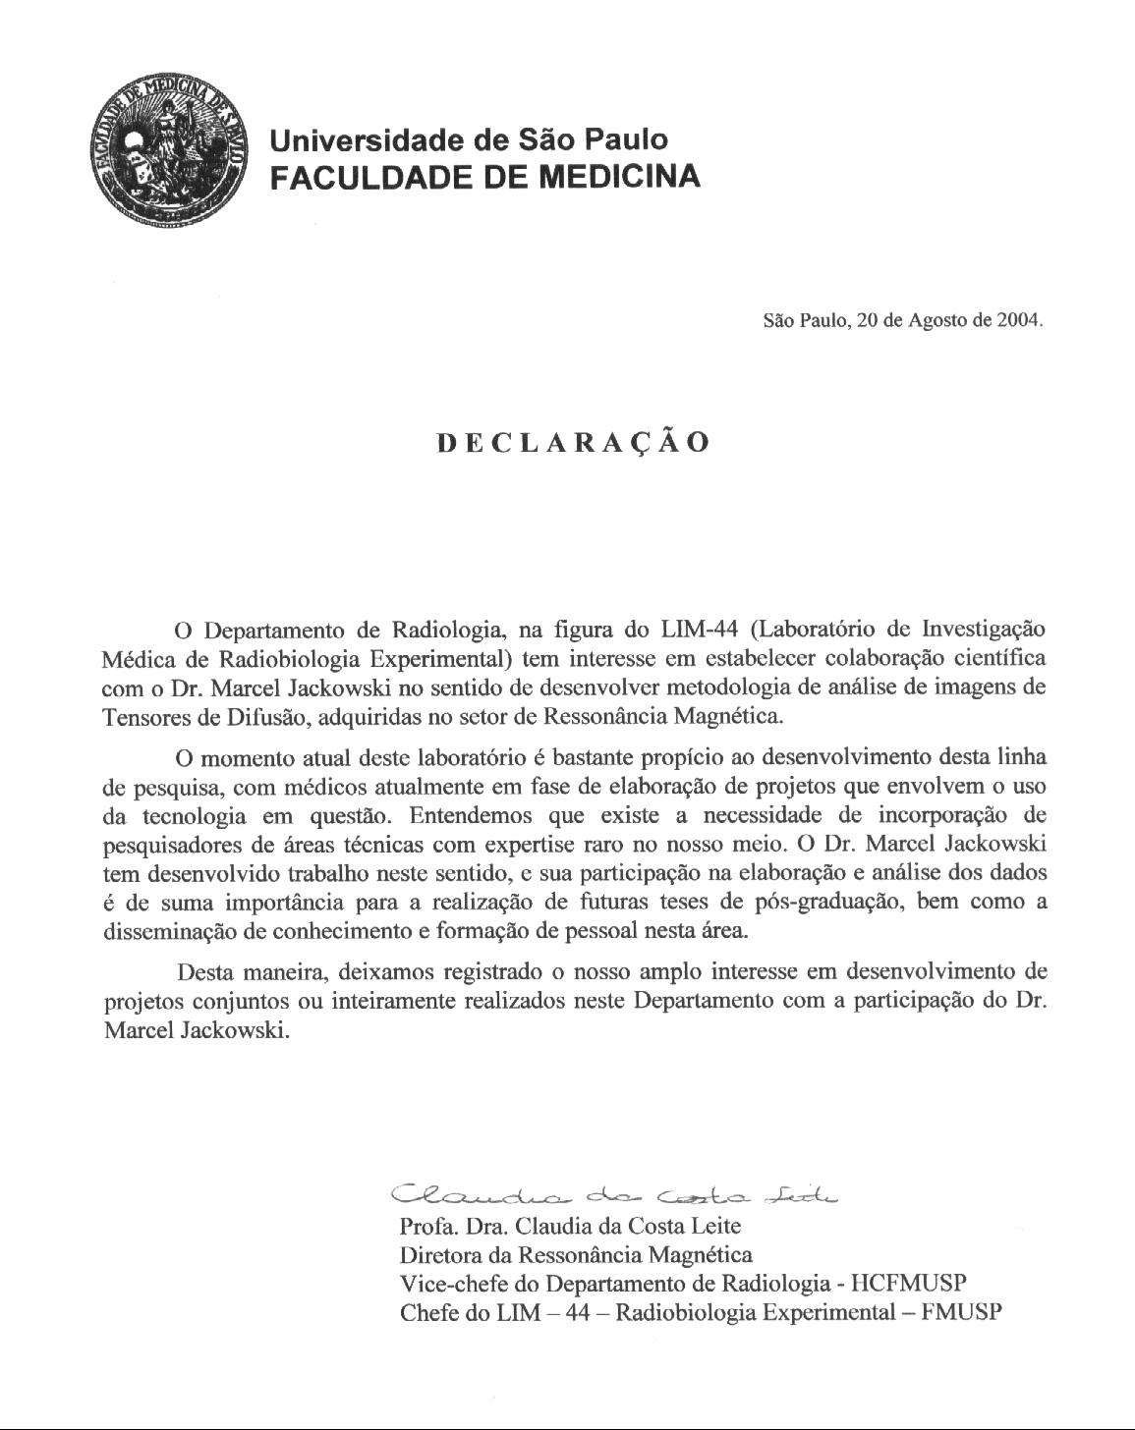

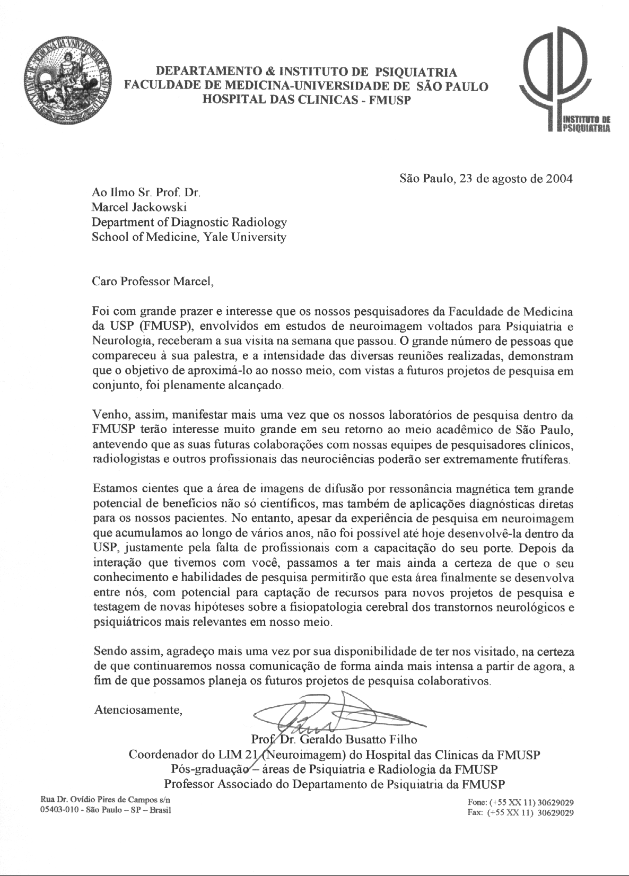

# Documentos 6.4

